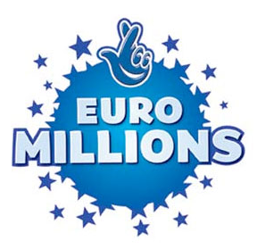

The United Kingdom Euro Millions
Lottery Promotion 2011/2012 Drew
Headquarters: 1a, Bexon Court Carlton
Nottingham shire Nottingham NG4 1SQ Essex
United Kingdom
(Customer Services Hot Line)
Tell: +44 703-1821779/ Fax: +44 8704780473
Ref: UK/9420X2/68 /Batch: 074/05/ZY369

WINNING NOTIFICATION
Dear Sir/Madam,

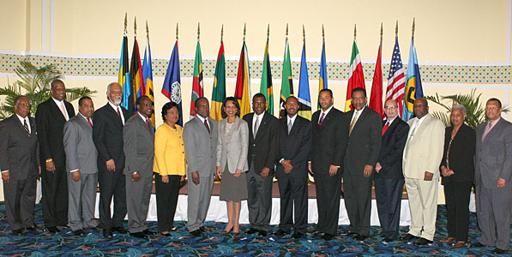
We happily announce to you the draw (#954) of the 2011 UK Euro Million online International Lottery program held on Tuesday 10th May 2011. Your e-mail address attached to Serial number 5368/02 drew the lucky numbers: 11-18-20-23-32-48(bonus no 25.), which subsequently won you the Lottery in the 2nd category i.e. match 5 plus bonus. You have therefore been approved to claim a total sum of £820,000.00(Eight Hundred and Twenty Thousand Pounds Sterling Only) in cash credited to file KTU/9023118308/03.

Members of the UK EURO Million Lottery Board
All participants for the online version were selected randomly from World Wide Web sites through computer draw system and extracted from over 100,000 unions, associations, and corporate bodies that are listed online.
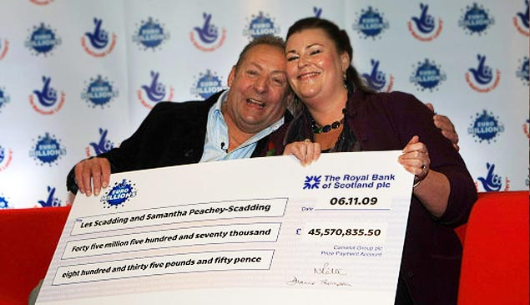
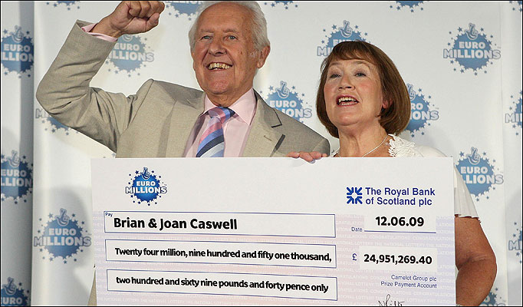

Les and Samantha (One of our 2009 Lottery Winners) Brian And Caswell(2010 Lottery Winners)

To file for your claims, please provide as stated bellow and contact our DPU office in South Africa:

FULL NAME………………………………

FULL ADDRESS…………………………..

SEX………………..AGE………….

OCCUPATION……………………

TEL……………………CEL…….

WINNING REF.N0……………..

WINNING SERIAL N0………..

WINNING BATCH N0……..

DPU Zonal Office South Africa
Director Claiming Department.
Mr. John Patrick
Tel: +27-735 805 762
Email: salottodept03@yahoo.com

UK Inquiry office of the International Relation officer.
Mr. Van Brandis
Customer Hot Line Tell: +44 703-1821779

Congratulations.

Yours faithfully,
Mrs. Julia Jenkins
(UK Online coordinator.)

DISCLAIMER:
The information contained in this e-mail and its attachments are intended solely for the use of the individual(s) to whom it is addressed and contains information that is confidential. If the reader of this e-mail is not the intended recipient, you are hereby notified that any dissemination, distribution, or copying of this e-mail is strictly prohibited. If you have received this e-mail in error, please immediately notify the sender and destroy the e-mail. Thank You. Ce courrier électronique est confidentiel. Si vous l'avez reçu par erreur,veuillez nous en aviser. Merci.
Scanned by IBM Email Security Management Services powered by MessageLabs. For more information please visit http://www-931.ibm.com/services/us/index.wss/oferfamily/iss/a1026954

N.B. Any breach of confidentiality on the part of the winners will result to disqualification. Please do not reply to this mail box. Contact your claims agent through his email contact above. All participants below the age of 16 years old are automatically disqualified.

Copyright Â© 2011 The Xanga web & UK National Lottery Inc.
All rights reserved. Terms of Service - Guideline

