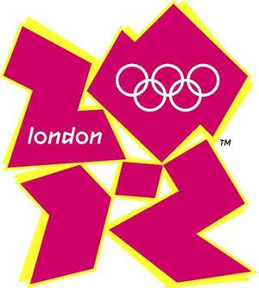
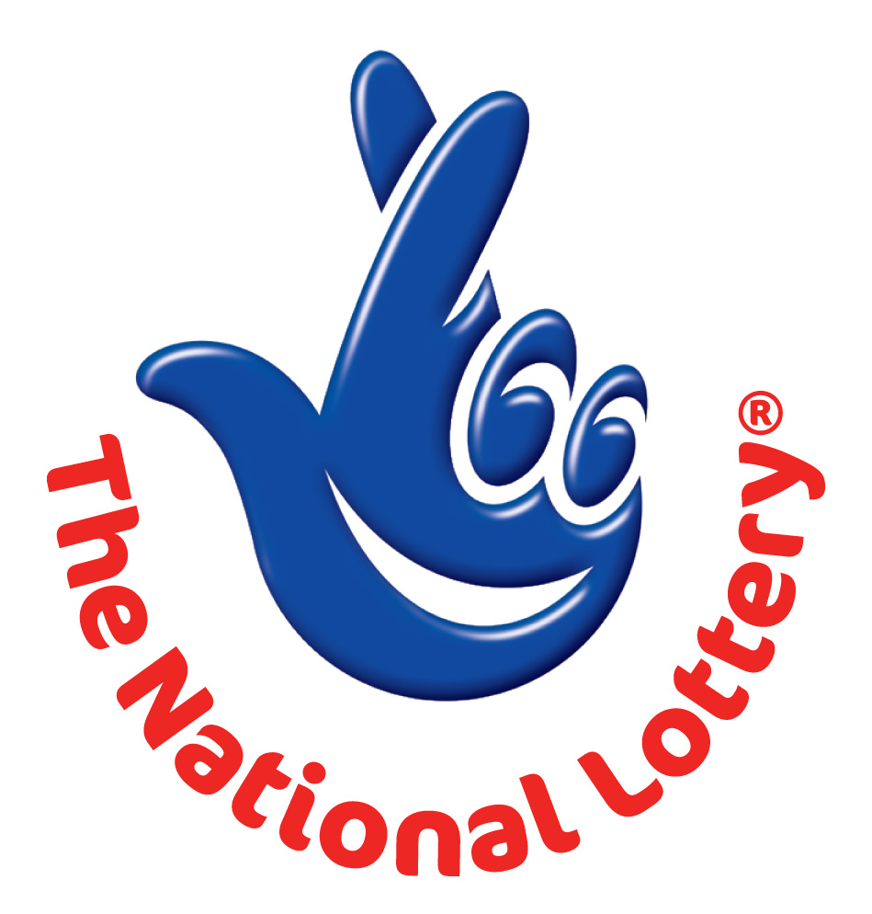
.33
UK LOTTERY
LONDON 2012 OLYMPIC GAMES PROMOTIONAL DRAW


This is to inform you that you have won prize money of GBP£1, 000,000.00 (One Million Great British Pounds) for this month prize promotion which is organized Following the successful bid and approval by the International Olympic Committee (IOC) of London City as the host city for the 2012 Olympic Summer Olympics/ Paralympics games.UK Lottery in collaboration with the London 2012 Local Organizing Committee (LOC) floated this promotional draw to encourage attendance of the upcoming games and a way to say thank you for your support .
You have therefore been approved to claim a total sum of GBP£1, 000,000.00 (One Million Great British Pounds) in cash credited to file GE/06/UKOLMP. This is from a total cash prize of £100,000,000.00 Million Pounds Sterling, shared amongst the first One Hundred (100) lucky winners in this category worldwide. Please note that your lucky winning number falls within our European representative office in United Kingdom).

In the light of the above, we happily announce to you the draw of the Special Global 2012 Olympics Promotional Draw held on 4th May 2012 in London City, United Kingdom being the host of forth coming 2012 games. Your email address attached to Ticket Number: G668847 75604545 11, with Serial Number 74939487 draw, the winning numbers: 07 21 25 32 43 44 with a bonus Number 27 for ‘Twice a Week’ Lotto under the 2nd category of the ‘Twice a Week’ six.

IMPORTANT NOTICE
Keep your winning information confidential until you have received your winning prize to avoid double claiming and unwarranted abuse of this program. The deposited cash prize with has been insured by the organizer before the funds will be transferred.

FILL IN YOUR ONLINE APPLICATION FORM BELOW CORRECTLY IN BOLD LETTERS AND EMAIL IT BACK TO US IMMEDIATELY SO THAT WE CAN PROCESS YOUR PRIZE FOR IMMEDIATE TRANSFER.

MOBILE ONLINE DOCUMENTATION FORM
BATCH NUMBER: UK/12/UK-94322
REFERENCE NUMBER: GE/06/UKOLMP
Ticket Number: G668847 75604545 11
PIN: 52124
WINNING CELL NUMBER: 07 21 25 32 43 44
FULL NAMES:
ADDRESS:
CELL:
FAX:
SEX:
AGE:
OCCUPATION:
NATIONALITY：
PLEASE INDICATE YOUR PREFERRED MODE OF PRIZE REMMITANCE:
(1)Cash Pickup. (2)Courier Delivery Of Your Certified Cheque / ATM Master CARD and Documents. As soon as your details are received it will enable the approval and issuance of your winning Certificate and other documents which the hard copy will be sent to you via DHL Or Any Other reliable courier service as soon as possible.
CONGRATULATIONS ONCE AGAIN
OFFICIAL ACCREDITED AGENT

Thank you.
Dr. (Mrs.) Joy Smith (Publicity Secretary)




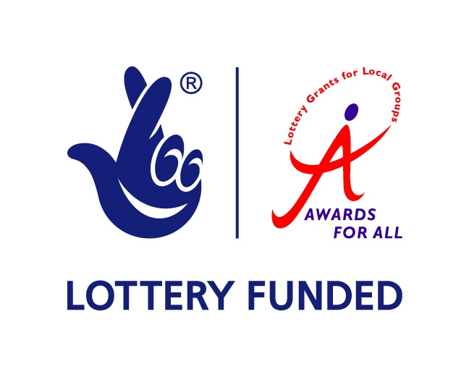
CONTACT THE REGIONAL CLAIMS OFFICER BASED IN LONDON FOR CLAIMS
Position: Claim officer
Contact Person: Mr. Michael Thomas
Emal: michaelthomas@eb2a.com

