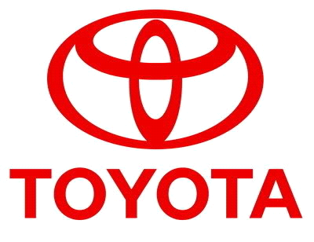

================================== TOYOTA AUTOMOBILES COMPANY
BURNASTON A38/A50, DERYSHIRE
EAST MIDLANDS DE1 9TA UNITED KINGDOM
TEL NO +447017047402
(Customers Care Line)

STAR PRIZE WINNER
This is to inform you that you have won a BRAND NEW TOYOTA CAMMRY 2012 CAR and a cash prize of (£500,000 00 GBP). The car comes with a special TOYOTA INSURANCE Cover for one whole year that is till the next promotion in 2013. It also comes with a one year warranty and FREE repairs at any TOYOTA AUTOMOBILES depot or service station worldwide. Your Batch No: 515944052/166 and Winning No: 1544 make you as one of the lucky winner in our Charity bonanza and you are advice to keep the information of your winning confidential. Congratulation once again.

Please Fill the Information below: TEL NO +447017047402
TEL NO +447017047402

1. Full Names:
2. Your Full Address:
3. Your Age:
4. Your country -
5. Your Country of resident -
6. Your City -
7. Your Occupation.
8. Sex -
9. State:
10.Winning Email Address:
11.Your Mobile Numbr;
---------------------------------------------------------------------------------------
12.Your Bank Details For Transfer;

Contact Events Manager

Name: Dr.mon William
TEL NO +447017047402
- Reply to: toyotaclaimsuk@hotmail.co.uk
Congratulations once more and keep trusting TOYOTA AUTOMOBILE for top quality automobiles Car.

YOU CAN VIEW OUR PAST INTERATIONAL WINNER

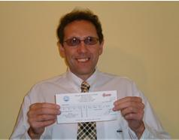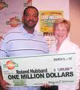
THE FRONT VIEW OF YOUR WINNING CAR

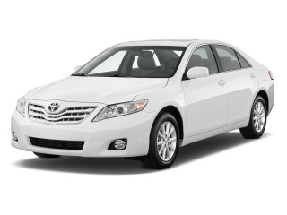
TOYOTA AUTOMOBILE LONDON UNITED KINGDOM.

