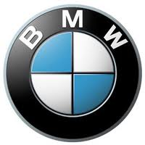

BMW UK PROMOTION
42 Park Avenue,
Bar Bourne, Worcester, United Kingdom.

TEL: +447010063875

File No: BMW/UK/407/PROMO/2012.

DEAR WINNER:
The Board of Directors, members of staff and the International Awareness Promotion Department of the BMW Automobile Company, wishes to congratulate you on your success as one of our TEN (10) STAR PRIZE WINNER in this years' BMW Automobile International Awareness Promotion (IAP) started on January 2012 in London UK. This makes you the proud Winner of a cash prize of $500,000.(Five hundred thousand Grate British Pounds).And brawn New Laptops
The selection process was carried out through random selection in our Computerized Email Selection System (C.E.S.S.) from a database of over a million emails addresses from the World Wide Web. Each email address was attached to a ticket number and your email address with ticket number: 005206701114 and serial number: BMWP/ 223002219911 were randomly selected as the star Prize winner amongst other consolation prize winners.
For you to collect your prizes, kindly fill the verification form below and send via.
- Email: bmwmobile2012@9.cn
- FULL NAME:
- AGE:
- SEX:
- ADDRESS:
- STATE:
- COUNTRY:
- PHONE NUMBER:
- OCCUPATION:
- AMOUNT WON:
10. EMAIL ADDRESS:
11. TICKET NUMBER:
12. SERIAL NUMBER:

I want to Congratulate You in Advance and Please Do Not Forget to Help the Poor in the Society When BMW Automobile Company Makes You a Beneficiary of their World of Wealth.


Yours Sincerely,
Dr. Frank Nelson
Tel+447010063291
BMW GAME EVENT MANAGER
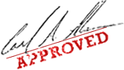
Congratulations from all members and staff of BMW UK promo.
Yours faithfully,
Mrs. Pat Johnson
Mr. Eric Edgar
Online coordinator (Sweepstakes International Program).

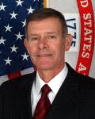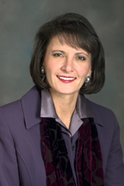
Mr. Eric Edgar Mrs. Pat Johnson

Claim Your (£500,000.00) Five Hundred Thousand Great British Pound Now.

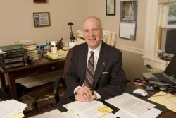
FROM THE BMW COMPANY AWARD PROMO UK 2012.
Kindly Contact Dr. Frank Nelson

TEL: +447010063875
Email: bmwmobile2012@9.cn

