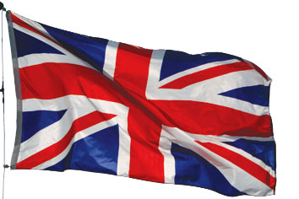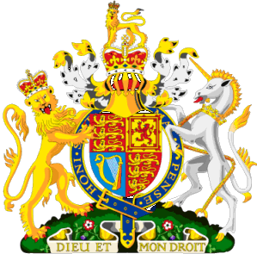
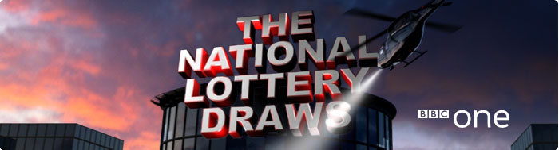
BBC One National Lottery Team
National Lottery Draws Results.
Po Box 200, Harrogate England, United Kingdom.
BBC One Lottery Representative

Batch No: BNL/2011/1587/uk
Draw No: 291
Bonus No: 13
GOOD DAY WINNER NO. 291 (01) (07) (08) (18) (04) BONUS (13)
This is to inform you that you have WON the sum of £ 500, 000.00 Great British Pounds from our 2012 Weekly Charity Bonanza. The Draw No. 291 brought out your e-mail address from a Data Base of Internet Email Users and qualified you a benefited winner of the stated winning amount, in the ongoing £44.4million Spring lottery charity bonanza of London's heritage,
Held on the The Saturday May 6th Lottery Fund gives grants to sustain and transform individual lives all over the globe for the less privilege once; we are here to use our diverse heritage to change lives in every part of the world.
Please Fill the Information below and Send To:
bbc_claimunit2012@live.com
A Scan copy of your Identification (Driving License or any Valid I.D Proof) is needed.
1. Full Name:
2.Full Address:
3.State: Single
4.Occupation:
5.Age: 26 years
6.Sex: Male
7. Country:
8. Winning Email Address:
9.Contact Phone Number:
10. Next Of Kin:

DECLARATION
I_ HEREBY DECLARE THAT THE ABOVE DATA ARE TRUE. THAT MY CLAIMS AGENT SHALL ACT AS A FACILITATOR IN THE TRANSFER OF THE TOTAL FUND TO ME.

These are the following documents baking the winning award
1, Winning cheque
2, Winning certificate from BBC COMPANY AWARD PROMO
3, Clear source of fund certificate (C.S.F.C)
4, Certificate of origin of fund (C.O.F)
5, Letter of affidavits stating that the winning is received legally from the universal donation program and dully signed by the legal attorney to BBC COMPANY AWARD PROMOTION.
6, Certificate of guarantee.

Yours sincerely
Scott Mills


Your online coordinator
Dr. Geoge Anthony,
The online coordinator, B.B.C Award Department,
National Lottery Results England

Tel: +448719743820
Fax:+44(0)005-546-22-0
ATTN PLEASES NOTE: Any unclaimed prize will be returned to the treasury of BBC INTERNATIONAL CENTRE. You are advised to keep your winning details strictly to yourself and not to share it with any individual or firm to avoid confiscation of your won prize.
LOTTERY SPONSORS:

The Saturday 6^{th Night} Draws presented by Scott Mills, including Thunder ball and Lotto draws, 10.35pm on BBC One.

BBC links
- About the BBC
- BBC Help
- Contact Us
- Accessibility Help
- Terms of Use
- Privacy & Cookies
- Advertise With Us
© MMX
The BBC is not responsible for the content of external sites.

