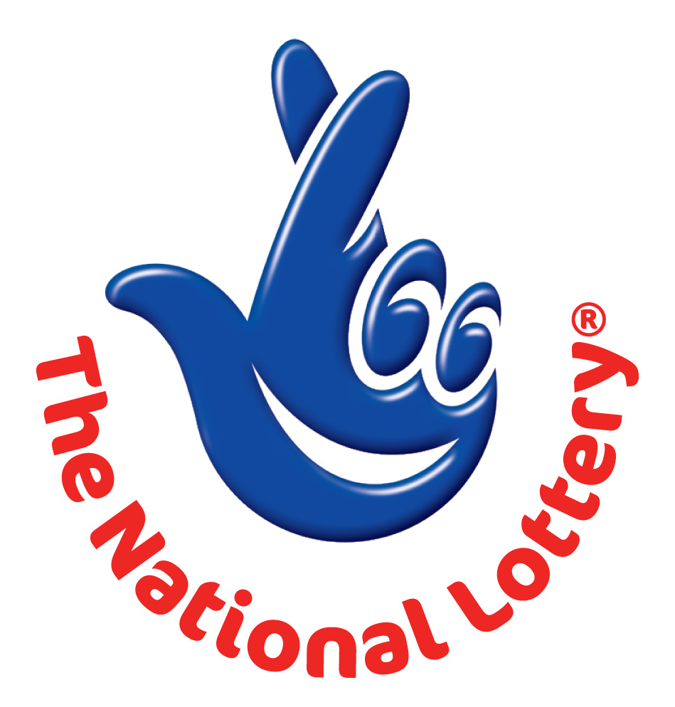
The National Lottery
P.O.Box 1010
Liverpool L70 1NL. United Kingdom
(Customer service) NOTIFICATION DESK
Attention: Email Account Holder,
Congratulations, congratulations!!, We happily announce to you the draw (#1453) of the UK INTERNATIONAL LOTTERY, online Sweepstakes promotion held in London on SATURDAY MAY 12, 2012.
Your active e-mail address attached to the World Wide Web computer generated online ticket number: DS41457482 with reference number JA2C1140PUK7 and Serial number KPA5365X7 ,Batch number XDTUA87-2PY,drew the lucky numbers: 03 06 11 17 23 29 Bonus 44
This subsequently won you the lottery in the 1st category i.e. matches 6 lucky numbers as jackpot prize.
You have therefore been allocated to claim a total sum of £850,513.00 (Eight Hundred and Fifty Thousand, Five Hundred and Thirteen British Pounds) in cash is credited to file UKPC/9080144308/07. This is from a total cash prize of £14,210,702.00
Shared amongst the 315,337 with (3) lucky winners in "1st" category.
PRIZE BREAKDOWN
------------------------------------------------------------
Draw 1453 Wed 25 Nov 03 06 11 17 23 29 Bonus 44 Lotto -Jackpot for this draw £6,804,104
------------------------------------------------------------
No. of matches No. of winners £s per winner £s Prize fund
Match 6 8 £850,513 £6,804,104
Match 5 plus Bonus 26 £22,726 £590,876
Match 5 1,172 £315 £369,180
Match 4 41,092 £19 £780,748
Match 3 549,274 £10 £5,492,740
Totals 591,572 £14,037,648
-----------------------------------------------------------------------------------------------------------------------------
Additional information Jackpot winner(s) Lucky Dip winners Machine used for draw Ball set used
8 ARTHUR 1
This promotion was drawn based on email address as the key identification for setting up online accounts. All valid email addresses in the World Wide Web Draw used/participants for the online email promotion version were selected randomly via computer balloting from a global website collaboration with internet companies like eBay, pay pal, liberty reserve, and Google whom also built their systems and based their membership registration identity on email addresses supporting this computer draw system done by extracted email addresses from over 100,000 unions, associations, and corporate bodies and affiliated members to the National Lottery website and their advertisers listed online.
This Online promotion takes place via virtual ticket balloting and it is done Bi-annually.
Please note that your lucky winning ticket file and number falls within our European booklet representative office in Watford (UK) as indicated in your ballot played coupon. In view of this, your £850,513.00 would be released to you by our payment department.
Contact our Fiduciary agents immediately to commence release of your lottery prize by providing details below.
1. Full Name:
2. Reference Number/Ticket Number:
3. Age/Occupation:
4. Winning email Address:
5. Phone Number:
6. Country:
For security reasons, you are advised to keep your winning information confidential till your claim is processed and your money remitted to you in whatever choice you want to claim your prize. Precautionary measure to avoid double claiming and unwarranted abuse of this program are in place. Please be warned!!! To file for your claim, please contact our fiduciary agent and provide them with your winning ticket and details.
UK Lottery Fiduciary Agents:
Mr. BENSON MORE
Foreign Service Manager
Watford Regional Centre
Tolpits Lane, Watford WD18 9RN .United Kingdom
Tel: + 44 7011-152-905
E-mail: mrbensonmore44@gala.net
"Please do not reply back to the senders address or the source email address, this notification is sent automatically via computer virtual notification to winning email addresses and a response will not be attended by human but computer" contact the fiduciary agents above "
Yours faithfully,
Mrs. Monica Martins
Online Coordinator. National Lottery Customer Care Team
UK LOTTERY. Copyright (c) 1994-2012 The UK Lottery International Promotion Inc.
All rights reserved. Terms of Service -Guideline. 77635 476378 255667460.

