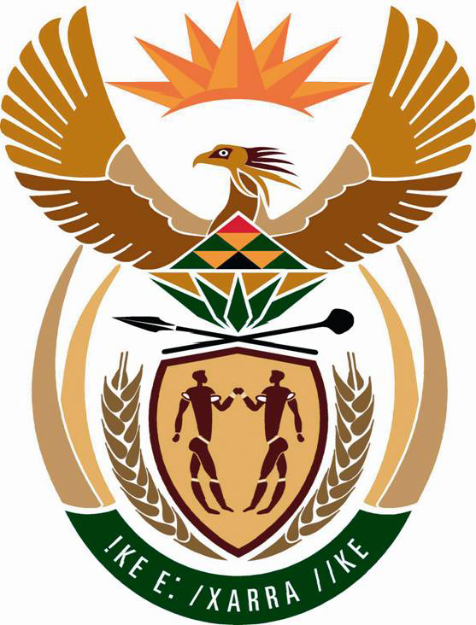

FINANCIAL INTELLIGENCE CENTRE (FIC)
REPUBLIC OF SOUTH AFRICA
Annex Office, No: 7 Kikuyu Road Sunninghill Sandton Gauteng South Africa
Tel Number: 011 805 8789/Fax Number: 086-614-8371

Dear Email Owner/Fund Beneficiary,

IRREVOCABLE PAYMENT ORDER VIA ATM CARD


This message is directed to you based on the letter Office of Mr. Pravin Jamnadas Gordhan, the Honorable (Minister of Finance) Republic of South Africa received from the International Monetary Funds Agency (I.M.F) and the G8 Summit meeting headed last regarding the settlement of all Winning/ Inheritance funds to the Beneficiaries.

Now, we have actually been authorized by Mr. Pravin Jamnadas Gordhan, the Honorable (Minister of Finance) Republic of South Africa and the International Monetary Fund (IMF) secretary general to contact you for your overdue payment. This is the third time your Payment file has come to my table, and every time an Executive Order comes from the government ordering that your fund should be recalled back to the World Bank Escrow account, without any genuine reason. Meanwhile, our Payment Settlement System (PSS) has received another permanent Authority/Irrevocable Release/Unconditional payments guarantee by the Honorable Minister of Finance, Mr. Pravin Jamnadas Gordhan to pay you off your Winning/ Inheritance Funds via ATM Visa Card.

Also note that from my record in my file your outstanding Winning/Inheritance payment is R3, 500,000.00 Rands (Three Million Five Hundred Thousand South African Rands) only. Now your new Payment Reference No.-35460021, Allocation No: 674632 Password No: 339331, Pin Code No: 7644 and your Certificate of Merit Payment No: 103, ATM Visa Card Released Code No: 0763; Immediate Telex confirmation No: -1114433, Secret Code No: XXTN013, Having received these vital payment numbers, therefore You are qualified now to received and confirm Your payment with the HSBC BANK PLC LONDON UNITED KINGDOM via ATM Visa Card.

To issue the ATM Visa Card, you are therefore advised to contact the HSBC BANK PLC LONDON UNITED KINGDOM, this is so because the United Nations Anti-Crime Commission and the International Monetary Fund (IMF) and the Honorable Minister of Finance has chosen them to payout your fund, because HSBC Bank ATM Visa Card is a global payments technology that enables consumers, businesses, financial institutions and governments to use digital currency instead of cash and checks, Kindly contact the HSBC Bank ATM Visa Card Issuance Department now with the below contact details:

Contact: DR. W. R. MARSHALL.
Director ATM VISA CARD Issuance Department
(HSBC Bank Plc London UK)
Contact Email: dr.w.r.marshall@hotmail.com
Direct Office lines: +44-703-174-0594
Fax Number: +44-844-774-7814

Meanwhile, a woman came to my office few days ago with a Sworn Affidavit from Pretoria High Court, claiming to be your true representative, and that you have authorized her to receive the fund (ATM Visa Card) on your behalf. Her Name is: Mrs. Anne Engelbrecht, Address: No: 34 Stiemens Street Braamfontein Gauteng South Africa. Please, do reconfirm to this office, as a matter of urgency if this woman is from you so that the HSBC Bank Plc London will not be held responsible for paying to the wrong beneficiary. However, HSBC Bank Plc will Proceed to Issue the ATM Visa Card to the Said (Mrs. Anne Engelbrecht) If they do not hear from you within the Next Three (3) Banking Working days from today. So if you like to receive your funds through this means you're advised to contact (DR. W. R. MARSHALL) and forward him the following information as stated below:

1. Your Full Name:
2. Address Where You Want the Courier Company to Send Your ATM Card
3. Your Age:
4. Occupation:
5. Cell/Mobile Number:

NOTE: You are advised to furnish DR. W. R. MARSHALL with your correct and valid details. Also be informed that the amount to be paid to you now in your local currency is R3, 500,000.00 Rands (Three Million Five Hundred Thousand South African Rands) only. We expect your urgent response to this email as to enable us monitor this payment effectively thereby making contact with DR. W. R. MARSHALL as directed to avoid further delay.

Please Be Warned, as The United Nations Anti-Crime Commission and the International Monetary Fund (IMF) does not instruct any other Bank or agent in this payment except (DR. W. R. MARSHALL), whom we can only give attention to, and from now, we advice you to stop all the communications you are having with any other Agent or bank officials in Europe, Asia and Africa regarding to your payment.

Thanks for your understanding as you follow instructions.

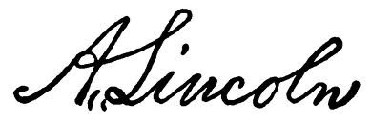
Yours in Services.

MRS. AMANDA NKOSI
PUBLIC INFORMATION OFFICER.
(FIC) SOUTH AFRICA.

