

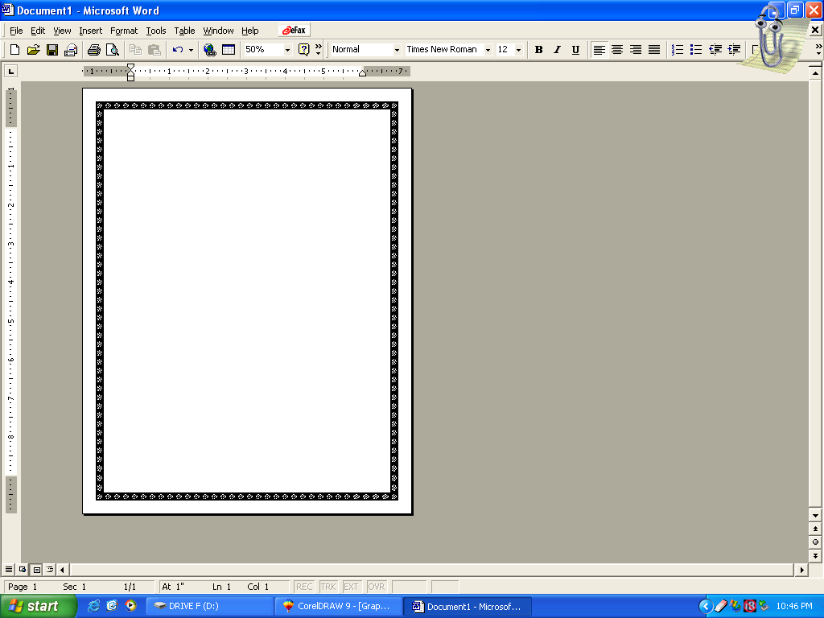
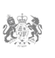N,

CONGRATULATION!!!

GOOD NEWS!!!

Your have won the sum of $2,100,000.00 {Two Million One Hundred Thousand Dollars} Your EMAIL ID was randomly selected among the lucky winners in our BMW YEARLY PROMOTION, your serial number is SA9627,

To claim your money contacts the representative agent:

Name: Mr. Paul Khumalo

Email: mr.paulkhumalo@gmail.com
TEL: +27-72-193-4319

And ensure that he register your winning.

Regards,

Mrs. Susan Zuma
Official Seal
Notary Public #021612
South African Gaming Commission

