

SCD6 Economic and Specialist Crime OCU, Wellington House, 67-73 Buckingham Gate, London, SW1E 6BE, London, SW1E 6BE

For The Kind Attention: Fraud Victim/Beneficiary

Your attention is drawn on our recent investigation report conducted in United Kingdom, which was in conjunction with the CIA, the international monetary funds (IMF) and THE METROPOLITAN POLICE. It has been clearly established through the intensive scrutiny of the above-mentioned financial crime security agencies that you have been a victim of the African Internet scam activities. From the investigation report, it has been proven through the record that you have paid some amount of money to these Africa scam artists with their European associates, running into thousands of dollars.
Due to the pressure and several complains from most frustrated victims from the international community, as well as the United Nation, the British Government empowered this office to look into these cases and your case was also reviewed for compensation.
Please you are therefore advised on the strength of this message to stop further contact either email or telephone correspondences with these Individuals or their cohorts abroad whom you may have been -dealing with in the recent past.
From investigation, it was revealed that you were being deceived into believing hoax inheritance money purportedly to have been left for you by a late relative, or an inflated contract sum waiting to be remitted into your account. This is pure scam and no such inheritance/contract/lottery money existed.
The government in its magnanimity and coupled with pressure from the international community, has approved for your compensation of the sum of $520,000,00 (Five Hundred & Twenty Thousand Dollars).through the official payee bank of Absa Bank of South Africa, payee officer, tell: +27788223191 fax:fax:+27862655594 email:willzuma@gala.net: Attn Mr. Will Zuma. Be informed that this payment will be made directly to your bank account via swift telegraphic transfer with REF N0: BBYUK/REG1958755

Please respond swiftly to this message with your receiving bank account details for processing of your payment such

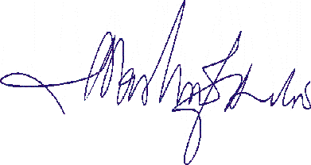
Yours truly,

CONFIRMED REGISTRAR
William S. Smith, SCD6
ECONOMIC AND SPECIALIST CRIME OCU

THIS MESSAGE >IS HIGHLY CONFIDENTIAL AND FOR THE USE OF THE ADDRESS ONLY>
AS STATED ABOVE > PLEASE NOTIFY> THE SENDER BY TELEPHONE OF ANY MISTAKE IN TRANSMISSION
A PROPERTY OF THE UK LAW ENFORCMENT AGENCY>< ALL RIGHT RESERVED

