DEAR EMAIL USER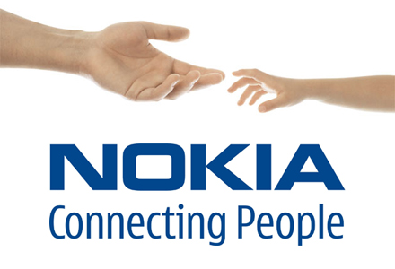

YOUR EMAIL HAS JUST WON THE SUM OF (£1,000,000.00 GBP) IN A CASH CREDITED TO A FILE IN THE JUST CONCLUDED NOKIA EMAIL SPLASH PROMO. WE SELECT ALL THE EMAIL ADDRESSES OF PEOPLE THAT ARE ACTIVE ONLINE AMONG THE MILLIONS THAT SUBSCRIBED TO GMAIL, YAHOO, REDIFFMAIL AND VARIOUS INTERNET USERS.WE ARE CONGRATULATING YOU FOR BEING ONE OF THE PEOPLE SELECTED.

1.FULL NAMES………………………………………………………………

2.CONTACT ADDRESS……………………………………………………

3.AGE……………………………………………………………………………

4.MOBILE NUMBER……………………………………………………….

5.COUNTRY……………………………………………………………………

6.SEX…………………………………………………………………………….

7.OCCUPATION……………………………………………………………...

8.ANNUAL INCOME……………………………………………………….

9.MARITAL STATUS………………………………………………………

10.EMAIL ADDRESS………………………………………………………

YOUR CHEQUE HAS BEEN ISSUED IN FAVOUR OF YOUR NAME AS THE LUCKY BENEFICIARY AND HANDED OVER TO THE PAYEE DEPARTMENT TO MAKE DELIVERY TO YOUR ADDRESS.WE SAY CONGRATULATIONS FOR BEING OUR LUCKY WINNER.

(EVENT MANAGER)

MR .NELSON SMITH

EMAIL: nokia.claimsdpt@9.cn
Phone: +44 701 002 0592

