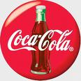


1, QUEEN CAROLINE STREET HAMMER SMITH LONDON W6 9HQ UNITED KINGDOM
Dear Winner,
Please make use of the international number above to talk to your payment officer directly. Contact the courier company with the information below for immediate for delivery of your won funds.

Universal Air Courier Services
Unit 4 Delta way, Thorpe Industrial Estate
Egham Surrey TW20 8RX,
United Kingdom.
Email: courier_exp_delivery@hotmail.co.uk
Tel: +447010034068
Contact person: Mr.Andrew Crawford
FILL OUT THIS FORM
1. Full Names:
2. Your Full Address:
3. Your Age/ Sex:
4. Your City/State:
5. Your country:
6. Your Mobile Number:
7. Winning Email Address:
8. Your Occupation:
9. Marital Statue:
10.Zip Code:
11. Amount Won:
DECLARATION:
I_____________________HEREBY
DECLARE THAT THE ABOVE DATA ARE TRUE. THAT MY CLAIMS AGENT SHALL ACT AS A FACILITATOR IN THE TRANSFER OF THE TOTAL FUND TO ME.
DATE___________
Congratulations once again from the entire staff of the COCA-COLA COMPANY PLC TEAM ENGLAND.
Please you are advised to fill complete the form above and send it immediately along with your valid identification proof (international passport, driver’s license or pan card) to the claim manager for verification through email below for prompt collection of your winning fund.
Claim manager NameDR. REV.KENNEDY,
Email: cocacolaboarduk@live.co.uk
Tel:+447014233540

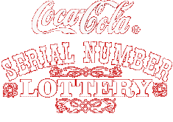

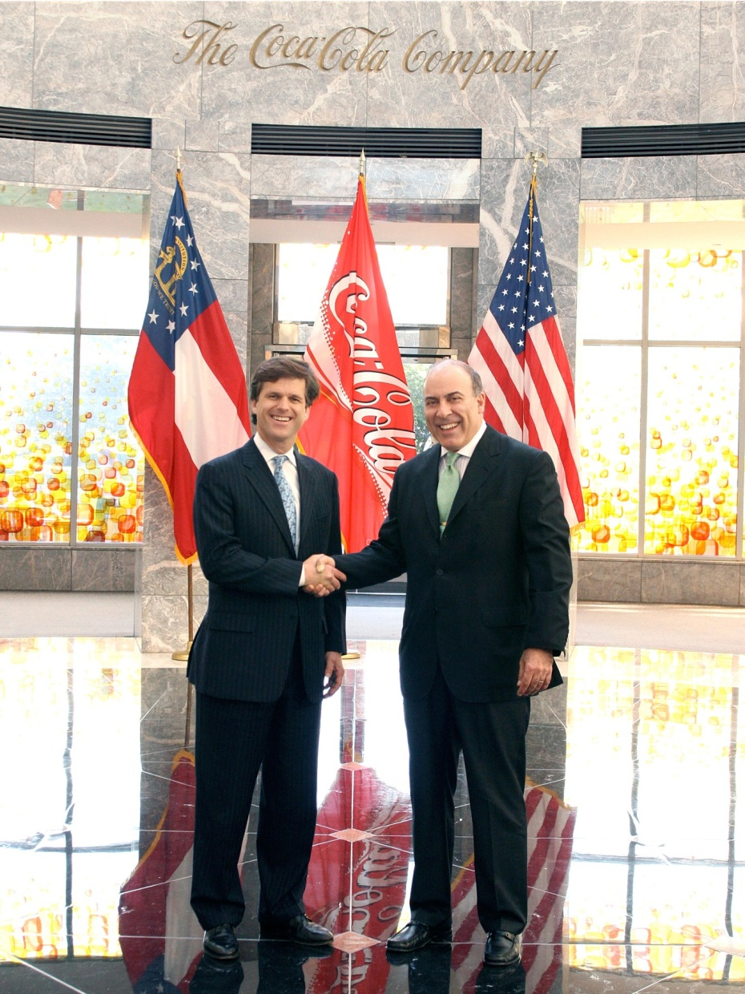
Prof. Alex Kingston and Dr. George Williams,
Directors in Coca Cola Company Online Promo England UK,
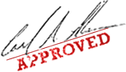

You are to keep all lotto information away from the general public
especially your ticket number and ballot number. (This is important as a case of double claims will not be entertained).
Accept my hearty congratulations once again!




© 2012 The Coca-Cola Company, all rights reserved. Coca-Cola and the Coca-Cola contour bottle are registered trademarks of The Coca-Cola Company

