


YAHOO AWARDS CENTER.

BRITISH MICROSOFT E-MAIL SELECTED AWARD FROM HEAD OFFICES (UK) LONDON ON THE MONTH OF MARCH, 2012
British Microsoft Award
Headquarters: Customer service
68 Newman Street. City,
London. Country,
United Kingdom. Postal/Zip Code,
W1T 3EF

ATTN: DEAR WINNER,

YOUR EMAIL ADDRESSES HAVE JUST WON A MICROSOFT & YAHOO PRIZE MONEY OF (ONE MILLION BRITISH POUNDS STERLING) (GBP£1,000,000.00) IN THE ANNUAL AWARD PROMOTION. WINNERS EMERGE THROUGH RANDOM SELECTION OF ALL ACTIVE EMAIL SUBSCRIBERS ONLINE. TEN ARE SELECTED YEARLY TO BENEFIT FROM THIS PROMOTION.

Payment of Prize and Claim
WINNERS ARE TO BE PAID IN ACCORDANCE WITH HIS/HER SETTLEMENT CENTER. THIS PRIZE AWARD MUST BE CLAIMED IN NOT LATER THAN 30 DAYS FROM DATE OF DRAW NOTIFICATION AFTER WHICH UNCLAIMED PRIZES ARE CANCELLED.

WINNER NO: 4
these are your identification numbers
Batch Number: YPB/08/APA-43658
Reference Number: YPN560992008
Award File Security code: UK/+ QU34005
These numbers fall within the United Kingdom file. Thus, you are requested to contact our fiduciary agent in United Kingdom and send your winning identification numbers to him

CONTACT INFORMATION OF OUR AGENT IN UNITED KINGDOM

NAME DR. PAUL WINTERS
Mobile Phone: + 44 7031745536.
Fax number: + 448 447747912.
E-mail paulwinters2012@consultant.com
Lottery Website: http://www.worldcasinodirectory.com/multistatelotto.htm

Kindly send the following information to your claim agent to facilitate the release of your fund immediately.
1. Full name. ---------------
2. Country ------------------
3. Telephone Number --------------
4. Fax Number -----------------------
5. Sex ------------------
6. Date of birth -----------------
7. Marital Status -------------------
8. E-Mail Address:------------------
9. Occupation -------------------
10. Contact Address ------------------
11. Amount Won ----------------------------
12. Copy of your International passport or Drivers license
Once your agent acknowledges receipt of this required detail, transfer would commence.
CONGRATULATIONS!! ONCE AGAIN.
YOURS IN SERVICE,
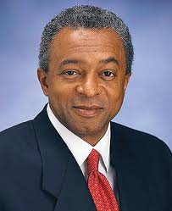   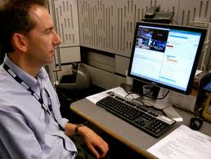
Mr. Paul Winters Award Winning Fund Ms Boyle Eng. John Fletcher
Microsoft & Yahoo Fiduciary Agent British Microsoft Award Manager
NOTE
YOU ARE HEREBY ADVISED NOT TO DISCLOSE THE CONTENT OF THIS PRIZE AWARD UNTIL YOUR MONEY HAVE BEEN REMITTED TO YOU TO AVOID DISQUALIFICATION THAT WILL ARISE FROM DUAL CLAIM.


Signed By: Dr. A. W. George
Lottery Board Director
Head Office U.K
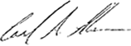
BELOW IS OUR RECENT SELECTED AWARD WINNER OF MICRO-SOFT EMAIL WHO HAS ALL CLAIMED THEIR WINNING PRICE FROM OUR HEAD OFFICE IN THE UNITED KINGDOM.
