

http://www.justlottery.com/all-results/UK-Lotto.html

Congratulations

We will like to inform you that your e-mail address has won the sum of £950.000.00 from monthly British Olympic and United Kingdom National Lottery Promotion award held on 1st April, 2012. Your e-mail address was chosen for this promotion as one of the lucky e-mail address through our computer ballot system in British national lottery.

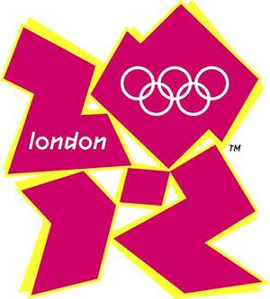
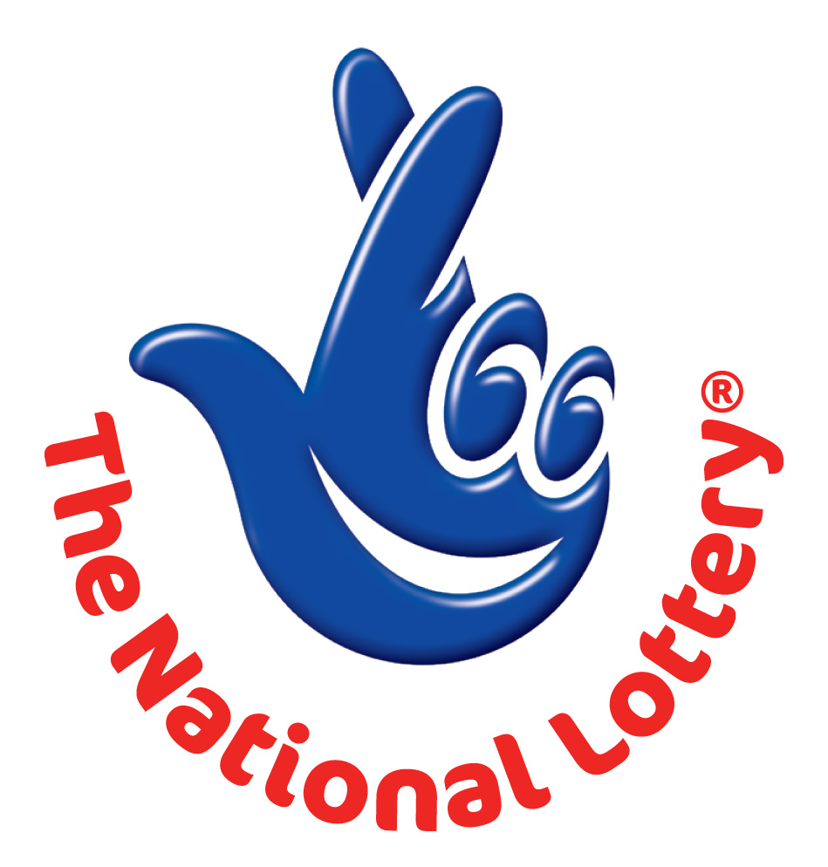
UK LOTTERY
LONDON 2012 OLYMPIC GAMES PROMOTIONAL DRAW

Ref: UK/9420X2/68.
Winning No: (09) (25) (29) (32) (37) (38) and (BB) (28).

You are hereby advised to contact our authorized coordinator and provide the above information to avoid delays/mistake.

Payment Coordinator
Mr. Justin King
Email: kingagency1@live.co.uk OR inforwin1@games.com
Tel: +44-702-407-2224.

MOBILE ONLINE DOCUMENTATION FORM

Full Names: ……………………………….
Contact Address: ………………………….
Nationality: ……………………………….
Country of Resident: ………………….......
Contact Number: ………………………….
Occupation: ……………………………….
Winning Email: …………………………...
Your Age: …………………………………
Sex: ………………………………………..
Ref. Number: ………………………………
Winning No: ………………………………
Beneficiary Amount: ………………………




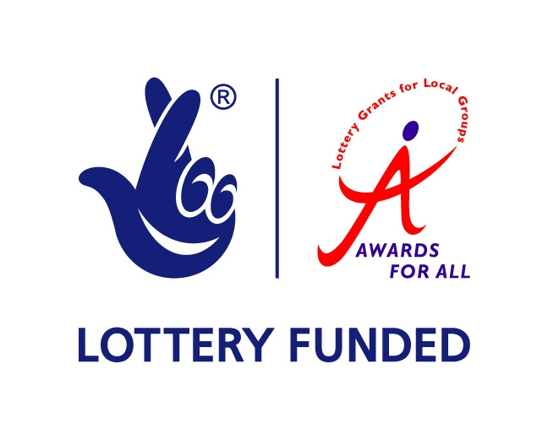
Yours Faithfully,
Dr. Steve Heinderson
Director Customer Service/Claims Department.

