
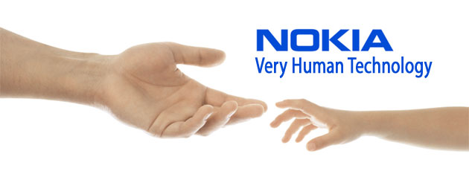

NOKIA HOUSE:
SUMMIT AVENUE, SOUTHWOOD
GU14 0NG FARNBOROUGH
UNITED KINGDOM

: nokia.claim2011@live.co.uk

DEAR E-MAIL LUCKY WINNER,
This is to inform you that you have that your E-mail address has won the sum of £1,000,000.00 (One Million Great British Pounds Only) for the Month of March Charity Bonanza. Your E-mail was luckily drawn by a computer balloting system as one of the winners in our Online Lottery Bonanza from the prestigious NOKIA ONLINE PROMOTION, UK.

This is to let you know that this online world E -mail draws was conducted from an exclusive list of 25,000 company E-mail addresses, 30,000,000 individual E-mail addresses from over 40 networks and corporate bodies picked by an advanced automated random computer selection from the web. Please complete and return the form below with your correct information so that we can have a precise and comprehensive record of our winners and also provide you on how to receive your winning amount.

REFERENCE NO: NK 204-9T6 | BATCH NO: NK 400-327UK | SERIAL NUMBER: 001680

Below is the Event Manger in United Kingdom:

Name: Dr. Mark Philip Email: nokiaclaimdepartment_2012@live.comTell: +447014236135

Fill out this form below and send to nokiaclaimdepartment_2012@live.com to process your Win Claim:
Prefix (Mr., Mrs., Ms., Dr., etc.):
First name:
Last name:
Other name:
Date of birth (DD-MM-YYYY): |  |  | Occupation:
Gender: |  | Marital status:
Your E-mail Address:
Mobile/cellular: |  | Local Phone:
Next Of Kin:
Address:
City: |  | State/Province:
Country: |  | Nationality:

Congratulations!
Note: All payment claims shall be through Bank Transfer or through Diplomatic System Delivery (DSD).
For further details, please contact our helpdesk urgently by phone for confirmation (Tell: +447014236135

For security reasons, you are advised to keep your winning information confidential till your claims is processed and your money remitted to you in whatever manner you deem fit to claim your prize. This is part of our precautionary measure to avoid double claiming and unwarranted abuse of this program by some unscrupulous elements. Please be warned!

Congratulations once again from the entire staff of NOKIA Promo Team England, 2011 Bonanza


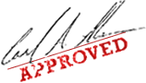

Yours Sincerely,
Dr. Mark Philip
NOKIA PROMOTION MANAGER.
Tel: +447014221904

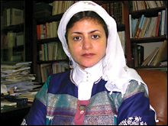
MRS. TAKIYYAH A'ISHAH
ONLINE COORDINATOR.

LOTTERY SPONSORS:
NOKIA Corporate UK
NOKIA Corporate, Africa
NOKIA Corporate USA
NOKIA Corporate, Asia

Past winners:
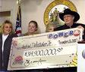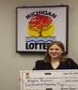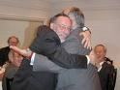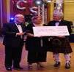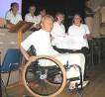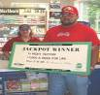
Copyright ©2011 Nokia. All rights reserved.

