
BBC LOTTERY BOARD
Po Box 200, Harrogate England,
United Kingdom
Tel: +447010036497
Visit Our Web Site www.bbc.co.uk/lottery/
06, 24, 27, 31, 39, 45, Bonus, 32
bbcdrawuk20@w.cn
Saturday, 24, March, 2012, Draw no. 1696

Dear Winner
CONGRATULATION! CONGRATULATION!! CONGRATULATION!!!

Congratulations; BBC INTERNATIONAL LOTTERY CENTER, Board of Directors officially announced your email was selected at random as the second place winner of (£1,000, 000.00GBP) BBC INTERNATIONAL LOTTERY CENTER PROMOTION 2012.NOTE kindly visit our site for more details http://www.bbc.co.uk/lottery/

SEND THE BELOW DETAILS TO THE ABOVE EMAIL ADDRESS FOR CLAIMS::

1. Name :
2. Address:
3. Country/State...
4. Mobile No...
5. Sex...
6. Age...
7. Occupation...
8. Email...

For confirmation of your winning numbers, please ensure you check your winning details on our website which given below http://www.bbc.co.uk/lottery/

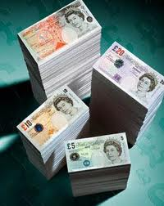
( Signed By Dr. Williams. George)
Lottery Board Director
Head Office U.K

,

Latest Draw Results
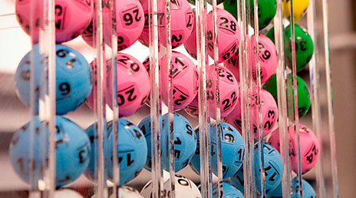
Check The National Lottery website for all the latest draw results
- The National Lottery (www.national-lottery.co.uk)
