
BBC LOTTERY BOARD
Po Box 200, Harrogate England,
United Kingdom
Tel: +447014236226
Visit Our Web Site www.bbc.co.uk/lottery/
01, 03, 16, 20, 37, 40, 15, Bonus, 19
Sat 17 Mar 2012 Draw 1694
Dear Winner
Your e-mail has won you £1,000,000.00(BRITISH POUNDS) from the BBC LOTTERY on our 2012 charity bonanza. The draw No. 1690 brought out your e-mail address from a Data Base of Internet Email Users and qualified you a beneficed winner of the stated winning amount.

You are to contact the claim manager via e-mail (bbclivedrawuk@hotmail.com.)providing the below stated information for the processing of your claims.

1. Name :
2. Address:
3. Country/State...
4. Mobile No...
5. Sex...
6. Age...
7. Occupation...
8. Email...

For confirmation of your winning numbers, please ensure you check your winning details on our website which given below http://www.bbc.co.uk/lottery/

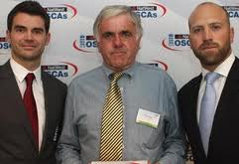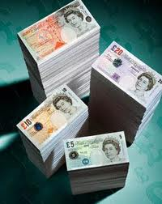
Prof. Alex Kingston and Dr. George Williams,
Directors in BBC LIVE UK Plc Online Promo England UK,



