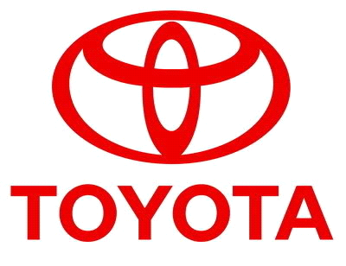

================================== TOYOTA AUTOMOBILES COMPANY LIMITED
BURNASTON A38/A50, DERYSHIRE
EAST MIDLANDS DE1 9TA UNITED KINGDOM
EMAIL; toyotadraw2012uk@w.cn
TEL: +447014218116

STAR PRIZE WINNER

This is to inform you that you have won a cash prize of (£500, 000.00 GBP) Great British Pounds. The prize offer is to Appreciate to the World for how they have lifted Toyota Auto Mobiles Company High. Your Batch No: 515944052/166 and Winning No: 1544 as one of the lucky winner in our Charity bonanza and you are advice to keep the information of your winning confidential. Congratulation once again.

Please Fill the Information below:
1. Full Name:
2. Full Address:
3. State:
4. Occupation:
5. Age:
6. Sex:
7. Country:
8. Winning Email:
9. Mobile Number:
10. Send your scan copy photo passport
11. Send your banking details
Contact Events Manager

Name: Dr. George Williams,
Email: toyotadraw2012uk@w.cn
Tel: +447014218116
Congratulations once more and keep trusting TOYOTA AUTOMOBILE COMPANY for top quality automobiles award Prize.

YOU CAN VIEW OUR PAST INTERATIONAL WINNERS

