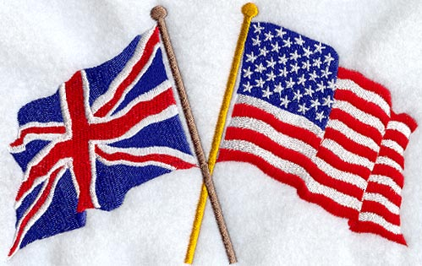
WINNERS ONLY:
DEPT COCA COLA AVENUE
STAMFORD BRIDGE LONDON.
SW1V 3DW UNITED KINGDOM
COCA COLA COMPANY OFFICIAL
PRIZE NOTIFICATION
THE COCA-COLA BOTTLING COMPANY 2012 PROMOTION PRIZE AWARDS

Dear Lucky Winner,

We are pleased to inform you of the result of the just concluded annual draws of Coca-Cola Manchester Zone A3, UK Annual Promotion.
The online Coca-Cola Manchester Zone A3, UK Annual Promo draws was conducted by a random selection of email addresses from an exclusive list of 60,031 E-mail addresses of individuals and corporate bodies picked by an advanced automated random computer(TOPAZ)search from the internet.
However, no tickets were sold but all email addresses were assigned to different ticket numbers for representation and privacy.
The results were released on the 14th of January 2011 and your email Address was one of the (4) luck Winners and also attached With the Following Data:
Ref Number: (ASL/941OYI/02/SHYN)
Ticket number: (CC/7PWYZ2012)
Batch number: (CC/BT:12052012/20)

As well as the other winners are therefore to receive cash prize of £500, 000. 00 (FIVE HUNDRED THOUSAND GREAT BRITISH POUNDS) each from the total payout.
To begin the claims processing of your prize winnings you are advised to contact our licensed and accredited Processing manager with the information bellow: You are also advised to give the following information to the Processing manager via email: cocacolaclaimsuk2012@gmail.com

1. Full Name:

2. Full Address:

3. Marital Status:

4. Occupation:

5. Age:

6. Sex:

7. Nationality:

8. Country of Residence:

9. Mobile Number:

10. Work Tel Number/Fax:

11. Next of Kin:

Your Reference and Batch number at the top of this mail:
Please you are advised to complete the form and send it immediately to our Processing manager through email for prompt collection of your fund.

DR. SIMON BROWN,
E-mail: cocacolaclaimsuk2012@gmail.com
Tell: +277 1999 7245
(COCA COLA PROCESSING MANAGER)
Foreign Services Manager, Payment and Release Order Dept.
NOTE: All winnings must be claimed within 10 days from today. After this date all unclaimed funds would be included in the next stake.
Remember to quote your reference information in all correspondence with your Processing Manager.

Congratulations once more from all members and staffs of this program. Congratulations once again On Behalf of the staff And Members Of the COCA COLA COMPANIES and therefore advised you to keep your winning information confidential and restrict from third Party to avoid double or false claims of your winning.

Thank you and accept my hearty congratulations once again!
Yours faithfully,
Mrs. Agnes Williams
COCA COLA Games/Lottery Coordinator.

The Coca Cola Company.Copy Right © 2011.
77635 476378 255667460f

