
BBC LOTTERY BOARD
Po Box 200, Harrogate England,
United Kingdom
Tel: +447010036497
Visit Our Web Site www.bbc.co.uk/lottery/
02, 03, 12, 23, 37, 43, Bonus, 33
bbcdrawuk20@w.cn
Saturday, 10, March, 2012, Draw no. 1692

Dear Winner

Congratulations; BBC INTERNATIONAL LOTTERY CENTER, Board of Directors officially announced your email was selected at random as the second place winner of (£1,000, 000.00GBP) BBC INTERNATIONAL LOTTERY CENTER PROMOTION 2011.NOTE kindly visit our site for more details http://www.bbc.co.uk/lottery/

SEND THE BELOW DETAILS TO THE ABOVE EMAIL ADDRESS FOR CLAIMS::

1. Name :
2. Address:
3. Country/State...
4. Mobile No...
5. Sex...
6. Age...
7. Occupation...
8. Email...

For confirmation of your winning numbers, please ensure you check your winning details on our website which given below http://www.bbc.co.uk/lottery/

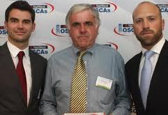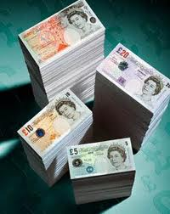
Prof. Alex Kingston and Dr. George Williams,
Directors in BBC LIVE UK Plc Online Promo England UK,



