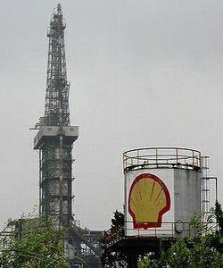

SHELL PETROLEUM DEVELOPMENT COMPANY ENGLAND.
No-7-Dock Way Sefiton Business Park,
20T40 4RT, England, United Kingdom.
Tel +447010056982
Fax: +447010056982
DR. PETER VOSER
Email: shellpetroleumclaimscenter70@hotmail.com

ATTENTION DEAR LUCKY WINNER,
YOUR WINNING VERIFICATION DETAILS PLEASE READ CAREFULLY AND DO THE NEEDFUL IMMEDIATELY.
We want you to accept our sincere congratulation as your email id have been short listed as one of the beneficiary of this year 2012 Shell Petroleum Company Email Lottery Sweepstakes.
You are advised to read and understand the below explanations perfectly to understand this email id users promo and how you emerged as a lucky winner of 2012 Shell Petroleum Company Email Lottery Sweepstakes.
ABOUT SHELL PETROLEUM DEVELOPMENT COMPANY EMAIL LOTTERY SWEEPSTAKES.
Shell Petroleum Company is one of the Biggest Multinational Oil and Gas Company in the world that specialized in exploring, refining and marketing of Crude Oil and has been rated largest oil and gas producing company 17 good times, ever since we started operation in 1916. Due to the profit max of the company, we were mandated by the United Nation (U.N), Organization of the Petroleum Exporting Company (OPEC), and the World crude oil monitoring forum to always use a reasonable percentage of our yearly profit to help the society at large.
It is in view of this that we have always empowered and assist some lucky individuals and non-governmental organizations like the (UNICEF, WHO, FUTURE GROUP,WORLD ACTION COMMITTEE ON AIDS) Financially, Shell Petroleum Company is committed to giving most of these organizations and lucky individuals a reasonable percentage of her annual profit to enhance and promote their activities for the sake of humanity.

On March 22nd, 1997 Global System for Email Users Communications (Email Users Technology) signed a memorandum of understanding with the Shell Petroleum where Shell Petroleum Development Company in conjunction with (U.K) National Lottery and a few others agreed to always donate a reasonable percentage of her yearly profit out to promote the use of Email id. i.e. Shell Petroleum Development Company since1998 enhances a hundred users of Email id irrespective of their network around the universes with financial assistance to liberate their world and help their society with a better living. After the successful completion of our financial year of 2011 which ended Dec! Ember 20 11,
Shell Petroleum Company Board has realized profit which is about 21% higher from what we realized in 2010.

It is in view of this that Fifty Million Great British Pounds (50,000,000.00) have been released to be shared among One Hundred active lucky email id Users for the year leaving each person with 500.000.00 Great British Pounds each.
I am pleased to inform you that your email id was selected to be amongest this one hundred Lucky for the year 2012 Shell Petroleum Development Company Endowment Fund.
HOW YOU WERE SELECTED: Global System for Email Users have always supplied Shell Petroleum Company Board with 50.000 of active email users yearly, and your email id was submitted for a random selection by our Computerized Programmed Ballot System and your email id was luckily selected among others therefore giving you the opportunity to claims for your self a total cash prize of Five hundred Thousand Great British Pounds (500,000.00) only.
WHAT TO DO NEXT: Your funds will be released to you any moment from now, but before any further details,
We need to have your information registered on our database as a lucky winner of Shell Petroleum Company Email Award,
Please provide us with the following information so as to enable the release of your won prize fund to you immediately.

1) YOUR FULL NAME: _______________

2) YOUR MOBILE NUMBER: ____________

3) YOUR NATIONALITY: _________________

4) YOUR STATE: ______________________

5) YOUR CITY: ______________________________

6) YOUR FULL RESIDENTIAL ADDRESS: ________

7) YOUR DATE OF BIRTH: ______________

8) SEX: ____________

9) YOUR MARITAL STATUS: ______________

10) YOUR OCCUPATION: _____________________

11) YOUR WINNING EMAIL ID: ___________________

12) AMOUNT WON: ____________________

13) SCAN A COPY OF YOUR ID PROOF TO US IMMEDIATELY: ________________

14) YOUR BANK NAME: ________________________
15) YOUR BANK ADDRESS: _____________________
16) ACCOUNT NAME AND NUMBER: _________
Please note that your winning lucky no is (SPDC-2012/52) as you were the 52nd beneficiary selected by the Computerized
Programmed Ballot System.
As soon as we receive the information required above,
You will be informed once your Winning Bank Demand Draft and all other accompanying legal winning documents is issued in your name and released for disbursement.
Kindly get back to me with the information requested above soonest so that your funds can be officially processed and released to you as explained above.

Email: shellpetroleumclaimscenter70@hotmail.com

Yours Sincerely.
Dr.John Bosco Williams,
Officer In-charge of Claims
Public Welfare Department,
Shell Petroleum Development Company,
London, United Kingdom.
Tel : +447010056982
Fax: +447-010-046-898.
Email: shellpetroleumclaimscenter70@hotmail.com
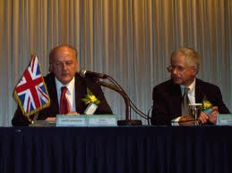
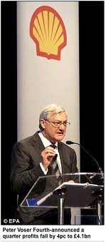
DR. PETER VOSER
Please call back immediately you have resent your details for confirmation on +447010056982
Copyright2012 Shell Petroleum Development Company United kingdom All Rights Reserve 