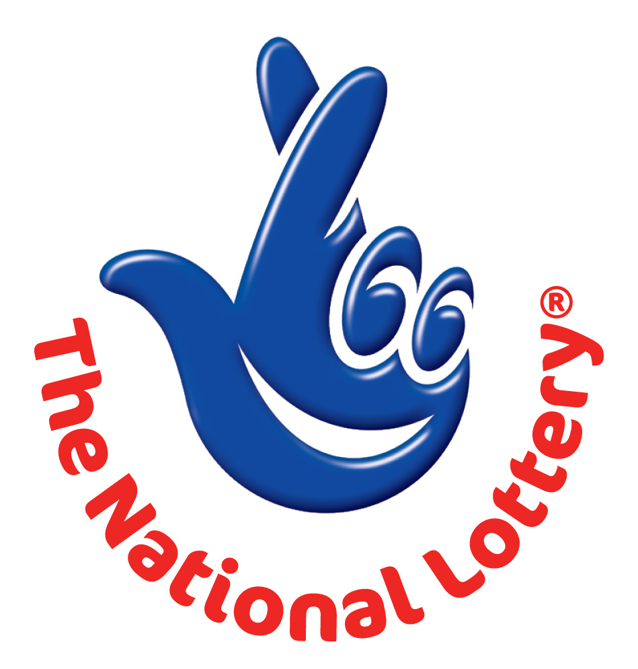
CANADA LOTTERY/ EMAIL DRAW ONTARIO 49
1550 Princess Street Kingston, ON, Canada, K7M 9E3
UK Office No 47 Se1 7na – Balking London United Kingdom
24hrs.Tell; +44 703-185-9080 Fax: +44 844 184 5942

SAT 27 SEPTEMBER 2011 - Ontario 49 WINNING NUMBERS
8 | 10 | 18 | 19 | 25 | 47 | Bonus 31

Attn: Winner,

We happily announce to you the draw of Canadian National Lottery the UK/CANADA online Sweepstakes International program held this year 2011.

You have won USD 1,000,000.00 (One Million United States Dollars Only) from Canadian lottery draw 2011.Your Email ID was one of the selected email all over the world in the lottery draw and it comes out one of the lucky winning number.

For us to process your winning for transfer you are advice to contact our judiciary agent with the details below in London for your payment.

Name: Mr. John Hill
Email:johnhilloo201@gala.net
Telephone: +44 703 1747 685

Please forward to him the following details below

1. Name (in Full):
2. Country:
3. Address:
4. Direct Telephone No:
5. Age:
6. Occupation/position:
7. Sex:

Congratulations!! Once again.

Yours in service,
Dr. (Mr.) Paul Smith.
[Publicity Secretary]

