
BBC LOTTERY BOARD
Po Box 200, Harrogate England,
United Kingdom
Tel: +447017014963
Visit Our Web Site www.bbc.co.uk/lottery/
Otober Draw No. 180
(01) (03) (04) (14) (31) (32) BONUS (26).DRAW 180
Dear Winner.

Your e-mail has won you £500,000.00 GBP from the BBC LOTTERY DRAWS 2011 charity bonanza. The draw No. 1556 brought out your e-mail address from a Data Base of Internet Email Users and qualified you a bonafied winner of the stated winning amount. It is online lottery draws which is usually organize every year.
You are to contact us via e-mail (bbconeuk99@hotmail.co.uk) providing the bel`ow stated information for the processing of your claims.

1 Name : =========

2 Address: =========

3. Country/State=====

4. Mobile No=======

5. Sex============

6. Age===========

7. Occupation======

8. Email==========

9 Your Full Name(s)=
10 Your Bank Name :
11 Name on Account :
12 Account Number :
13 Bank Address :

PLEASE:YOU ARE TO FORWARD YOUR COMPLETE DETAILS INCLUDING BANK DETAILS TO US FOR EASY PAYMENT
Mr. Mat Brown
Tel: +447017014963

For confirmation of your winning numbers, please ensure you check your winning details on our website which given below http://www.bbc.co.uk/lottery/

Claims Manager,
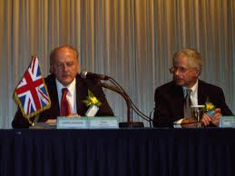
LOTTERY SPONSORS:
