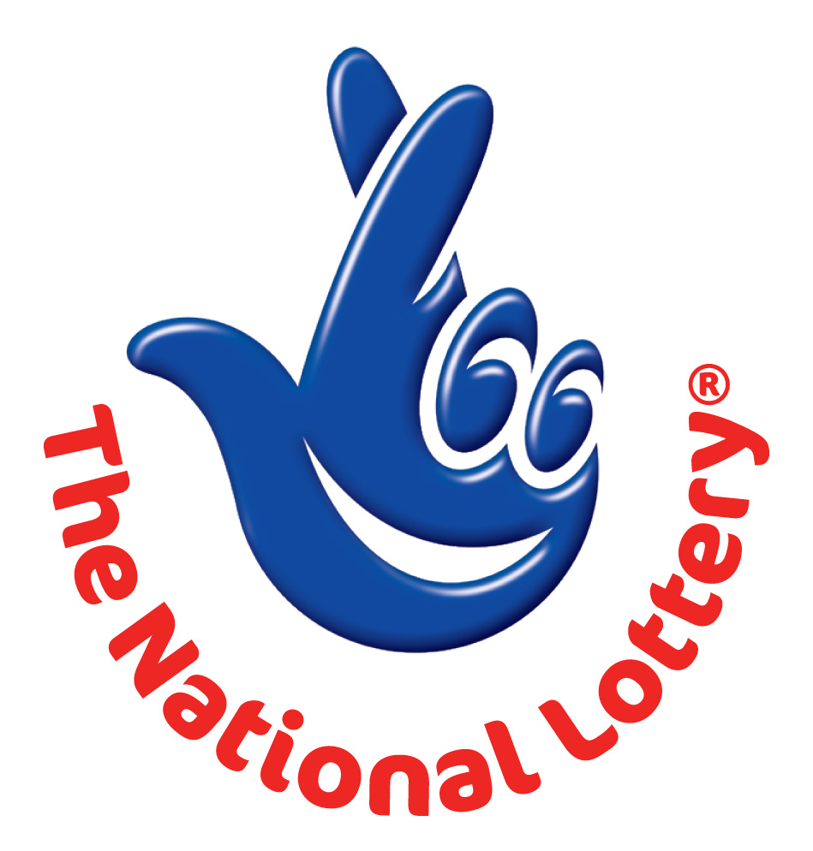

FROM: THE DESK OF THE DIRECTOR
INTERNATIONAL PROMOTIONS / PRIZE AWARD DEPARTMENT.

HEADQUARTERS: 8A KINGLY STREET, LONDON W1B 5PQ, LONDON UNITED KINGDOM

REFERENCE Nº: TTS/44412703/08
BATCH Nº: 20/1017/2DF

AWARD NOTIFICATION

Flash Budget Finance Lottery of British International Lottery Program wishes to inform you the results of the E-mail address ballot lottery program by the British International Lottery Program held on November 30th, 2011. Your email account was selected as a winner of Two Million Pounds Only.

This result is now made available to you and your email address attached in the Category A bonus ball 02, 03, 21, 24, 38, 44, and bonus ball 47. Participants were selected through a computerized ballot system drawn from company and individual email addresses users.

We advice that you keep your winning information confidential until your claims has been processed and your money released to you. This is part of our security protocol to avoid double claiming and unwarranted abuse of this program. For the release of your winnings, kindly contact your claims agent with the following details to expedite the processing of your prize winning.

1. Full name and address.
2. Country of Residence
3. Tel and fax number.
4. Occupation.

To begin your claim, please contact our Claim Manager at the Claim Department immediately with the following email address; nationallotto20102011uk@gmail.com OR call on telephone number +44 702 403 4576. All winning must be claimed not later than two weeks from the date of receipt of this email. After this date all prize winning will treated as Unclaimed

Note in order to avoid unnecessary delays; remember to quote your Reference and Batch numbers in all correspondence. Congratulations once again from all our staff and thank you for being part of our special quarterly promotional Lottery program.

Yours Sincerely,

Mr. Harry Wilson
(Information and Promotion Manager)

