
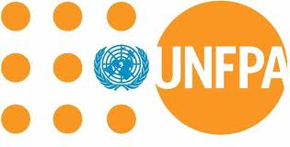

From the Desk of Mr.Rekha Thapa
Executive Secretary
The United Nations Population Fund
WEBSITE:http://www.unfpa.org/public/about/

Dear Beneficiary,

Based on the random selection exercise of internet websites and millions of supermarket cash invoices worldwide, YOUR EMAIL ADDRESS has been selected among the Ten lucky recipients to receive the award sum of £100,000.00 as donation/aid and prize award from the UNFPA international program. The United Nations Population Fund (UNFPA) is an international development agency that promotes the right of every woman, man and child to enjoy a life of health and equal opportunity. UNFPA, in conjunction with UAE, AU and the European Union (EU) is giving out these funds to various individuals all over the world for business, educational and Community development. This is our yearly promotions of which you were one of the winners. Congratulations!!!!

Please note that your Qualification numbers (P-333-7858) falls within our European office in LONDON UNITED KINGDOM. In view of this, your £1,000.000(One Million pounds sterling) would be released to you by of our payment office in London United Kingdom upon your contact with them.

Endeavour to contact the UNFPA office in UNITED KINGDOM with your Qualification numbers (P-333-7858) and your information’s below for onward processing of your donation funds. Do find the contact information of the officer in charge of claims as stated below:

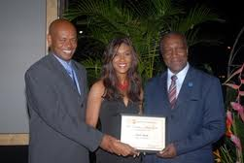
---------------------------------------------------------
Mr Marcus Lambert
United Nations Population Fund,
King Charles Street,London SW1A 2AH,
United,Kingdom.
Email:normanwebberagent@gala.net
Telephone: +44-703-197-5664

---------------------------------------------------------
ENTER PERSONAL DETAILS BELOW (Compulsory)
---------------------------------------------------------

Names:
Sex:
Age:
Occupation:
Current Address:
Country:
Valid Phone Number: Mobile Number:
Fax (optional):
Email:
---------------------------------------------------------

On behalf of UNFPA, kindly accept our congratulations.

Yours faithfully,
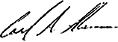
Birdnjo Henkin
Donation/Aid Co-ordinator

BELOW IS OUR RECENT SELECTED AWARD WINNER OF UNITED NATIONS FUNDS WHO HAS ALL CLAIMED THEIR WINNING PRICE FROM OUR HEAD OFFICE IN THE UNITED KINGDOM.
