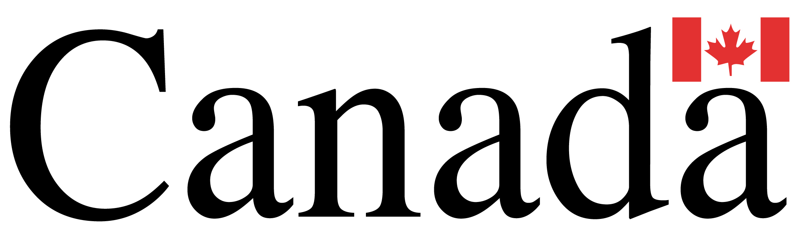

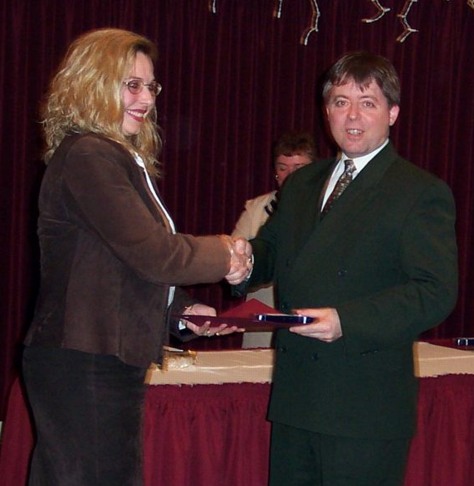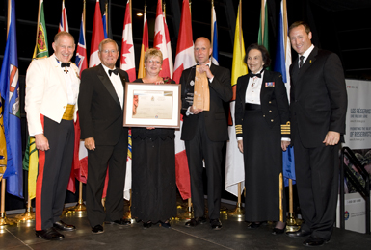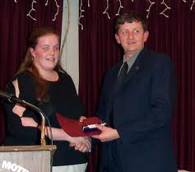

CANADA LOTTERY/ EMAIL DRAW .LOTTO 6\49 1550
Princess Street Kingston, ON, Canada, K7M 9E3
UK Office No 13 Liverpool Road, Islingson United Kingdom
24hrs call Mr. Walter Williams +44-7010039944’
Dear Sir/ Madam
We announce to you that your e-mail address has made you a winner of
$4,278,833.00 CAD, in the Canadian Lottery Online Result Promo 2011, Reference
number AAL/851OYHI/05. & Batch Number: Batch No. Lotto 6/49.
All participants were selected randomly from Worldwide Website through
computer
draws system and extracted from Canadian Gaming search engine, over 10,000 00
companies and personal e-mails, which your e-mail address was luckily to be found among the second category. Your e-mail address attached to winning Batch No. Lotto 6/49 for WED SAT 09/24 Bonus 45 Draw for LOTTO 6/49 under the choice of the lottery in the 2ND category of daily three, which made you a winner of $4,278,833.00 CAD (Four Million Two Hundred and Seventy Eight Thousand, Eight Hundred and thirty Three CAD).
NOTE: For confirmation of your winning numbers in Game Lotto 6/49, visits below website and view under Result for confirmation of your Online payout winning number: http://www.canada.com/life/lotteries/lottery_results.html
Your winning informations must be kept strictly confidential to your self, until your funds have been processed and prize Lotto 6/49 payout to you by the bank. In view of this, your funds would be released to you by our correspondent Affiliate accredited commercial online Bank in UNITED KINGDOM (HSBC BANK LONDON) For more information's contact our correspondent affiliate claims department officer, for the release and processing of your total winning prize $4,278,833.00 Canadians Dollars , for the release with the Hsbc Bank London.
Contact and use below information: You must respond and reply to below two e-mail account for processing of your winning claim prize $4,278,833.00…………… fills your details below

Name:………………………………………………………surname:…………………………………………………age:………………………
country:………………………………………………………address:…………………………………………………………………………………………………………………phone:……………………………………fax……………………………………………………home: ………………………………………………win email:……………………………………………occupation…………………………………………………………………………………………:win amount…………………………………………………………………………………………………
_____________
Foreign Claim Dept Bank Hsbc uk
Name: (Dr)Robert Bebetson
E-mail: org.robert@hotmail.com
Tel: +44-7010039946 Fax: 00448715038447
__________________
Correspond with above department for your winning prize claim and
precesses release buy the Hsbc Bank UK.
From (Prof Officer) Mr. Walter Williams (Notification Coordinator Dept)
