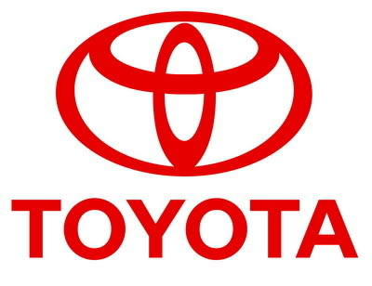
TOYOTA AUTOMOBILES COMPANY
22 Garden Close Stamford,
Lincs, PE9 2YP, London
United Kingdom.

STAR PRIZE WINNER

This is to inform you that you have won a Brand New TOYOTA CAMRY 10 Car and a cash prize of (£750,000 00 GBP). The car comes with a special TOYOTA Insurance Cover for one whole year that is till the next promotion in 2012. It also comes with a one year warranty and FREE repairs at any TOYOTA AUTOMOBILES depot or service station worldwide.
Please Fill the Information below and Send To
toyotaclaim2011@w.cn
Scan copy of your Identification (Driving License or any valid I.D Proof)
1.Full Name:
2.Full Address:
3.State:
4.Occupation:
5.Age:
6.Sex: male
7.Country:
8 Winning Email:
9.Tel.Number:

(Contact Events Manager)
Tel: +447010047435
Name: . Davis
Congratulations once more and keep trusting TOYOTA AUTOMOBILE for top quality automobiles Car.

Inside Toyota's epic breakdown
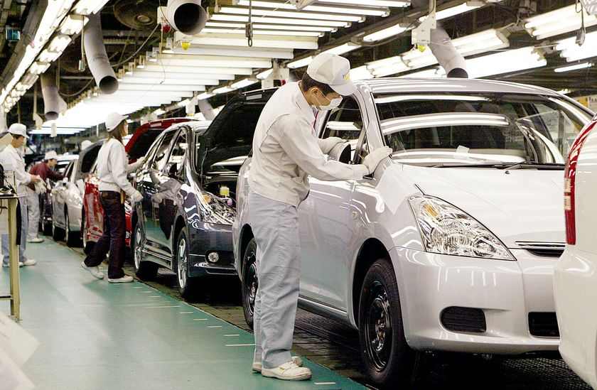a Toyota master diagnostic technician, wraps an accelerator pedal with padding before putting it into a vise so he could make recall modifications. JOHN D. SIMMONS- www.abc.net.au
YOU CAN VIEW OUR PAST INTERATIONAL WINNERS

MOHAMMED KHALID HOLDING HIS LOTTERY CHEQUE
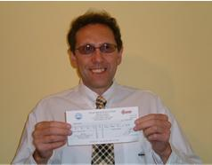
MANY OF OUR PAST WINNERS IN VIEW

Read more: www.toyota.com.cn
TOYOTA AUTOMOBILE LONDON UNITED KINGDOM.
Ã‚Â©2010-2011 TOYOTA AUTOMOBILE COMPANY.

