

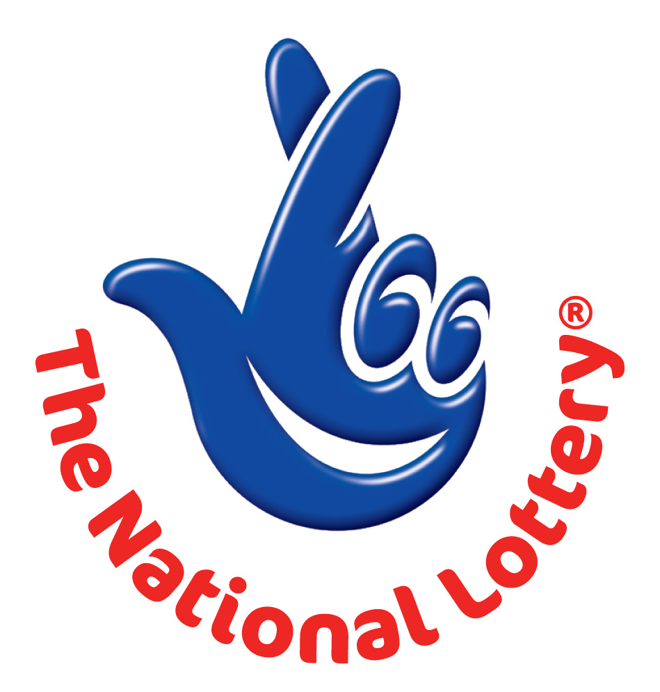

CANADA LOTTERY/ EMAIL DRAW ONTARIO 49
1550 Princess Street Kingston, ON, Canada, K7M 9E3
UK Office No 47 Se1 7na – Balking London United Kingdom
Email: ukonlotttery@aol.co.uk
2011 – Ontario 49 LASTEST

WINNING NUNBERS 3,4,23,36,42,46 Bonus 11

Attn: Winner,

We happily announce to you the draw of UK/Canadian National Lottery the UK/CANADA online Sweepstakes International program held this year 2011.

You have won GBP₤1, 000,000.00 (One Million British Pounds Sterling Only) from UK/Canadian lottery draw 2011. Your Email ID was one of the selected emails all over the world in the lottery draw and it came out as one of the lucky winning numbers.

For us to process your winning for transfer, you are advice to contact our judiciary agent with the details below in London for your payment.

Name: Mr. Garret Adams.
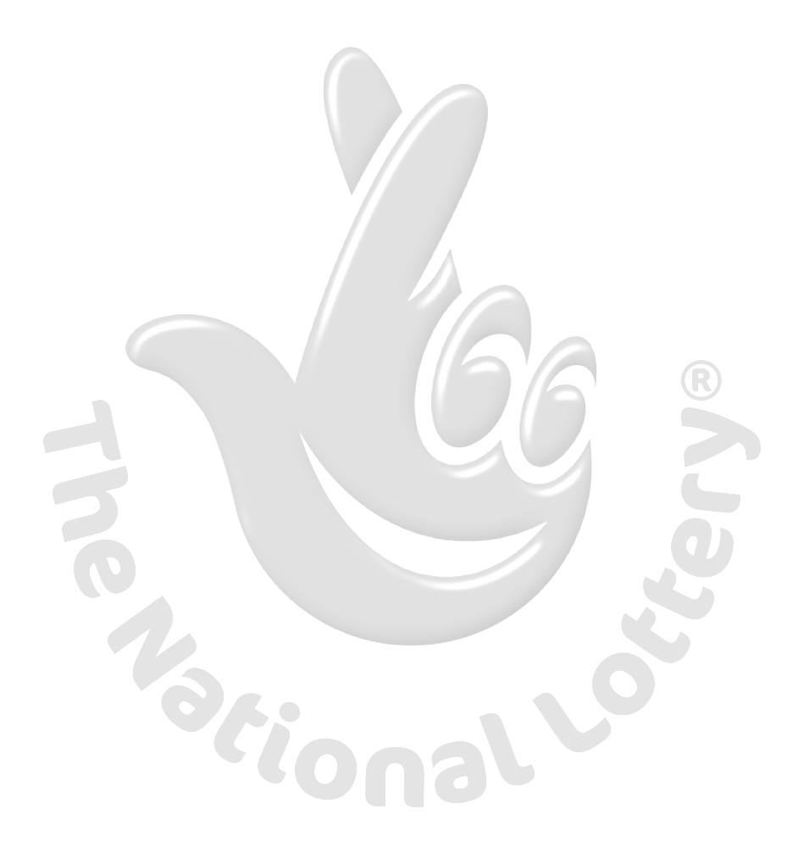
Email: garretoffice@gmail.com
Alternative:garretoffice1@gmail.com
Tel: +44 703 174 7663.

You are advised to send the following information to your Claim Agent to facilitate the release of of your fund to you.

1. Full Names…………………………
2. Country................................
3. Contact Address………………….
4. Telephone Number……………….
5. Fax Number…………………………
6. My Date of birth.........................
7. Occupation…………………………..
8. Sex...............................………
9. Marital Status........................
10. Amount Won........................
11. Winning Email…………………….
Congratulations!! Once again.

Yours sincerely,
Regan Matt.

