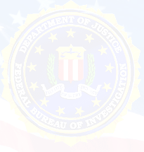
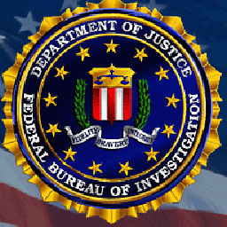

AGENT BRIAN D. LAMKIN
SPECIAL AGENT IN CHARGE
FEDERAL BUREAU OF INVESTIGATION
INTELLIGENCE FIELD UNIT
2635 CENTURY PARKWAY N.E.,
SUITE 400
ATLANTA, GA 30345 USA

URGENT ATTENTION

I am special agent Brian D. Lamkin; from the Intelligence Unit of the Federal Bureau of Investigation (FBI). We just intercepted/confiscated two (2) Trunk Boxes at the Harts field Jackson International Airport in Atlanta Georgia. We are on the verge of moving this consignment to the bureau headquarters. However, we scanned the said boxes and found out that it contained a total of USD$4.1M and some back up documents which bears your name as the owner of the funds. Investigation carried out on the Diplomat who accompanied these boxes into the United States, revealed that he was to make the delivery of the funds to your residence as these funds are entitled to you, being Contract/Inheritance overdue payments. The funds were from the office of the Ministry of Finance, Federal Government of Nigeria.

Furthermore, after cross checking all the legal documents we found in the boxes backing you up as the beneficiary of the funds, it became known to us that one vital document is missing. This document is very important and until we get that document, the boxes will be temporarily confiscated pending when you will provide it. The much needed document is the Diplomatic Immunity Seal of Delivery (DISD). This document will protect you from going against the US Patriot Act Section 314a and Section 314b. This delivery will be tagged A Diplomatic Transit Payment (S.T.D.P) once you get it.

You are therefore required to get back to me within 72 hours so that I will guide you on how to get the much needed document. Failure to comply with this directive may lead to the permanent confiscation of the funds. You are also advised not to get in contact with any Bank in Africa, Europe or any other institution, as your funds are here now in the United States of America.

AGENT BRIAN D. LAMKIN
SPECIAL AGENT IN CHARGE
FEDERAL BUREAU OF INVESTIGATION
INTELLIGENCE FIELD UNIT
2635 CENTURY PARKWAY N.E.,
SUITE 400
ATLANTA, GA 30345 USA

CONFIDENTIALITY NOTICE: This communication and its attachments may contain non-public, confidential or legally privileged information. The unlawful interception, use or disclosure of such information is prohibited. If you are not the intended recipient, or have received this communication in error, please notify the sender immediately by reply email and delete all copies of this communication and attachments without reading or saving them.

