
FROM THE DESK OF Mrs. Nancy Grasslands
T. Mobile UK National Lottery Information and Promotion Manager
T. MOBLE INTERNATIONAL LOTTERY AWARD PROMOTION:
1A CANADA SQUARE, CANARY WHARF LONDON E145DT, UNITED KINGDOM
www.national-lottery.com

Dear Email Account Owner

We are happy to inform you that your e-mail address has won the sum of £1,000.000.00 (One Million Great British Pounds Sterling) from monthly British National Lottery Promotion held on 5th October 2011. Your e-mail address was chosen for this promotion as one of the lucky e-mail address through our computer ballot system in British national lottery.


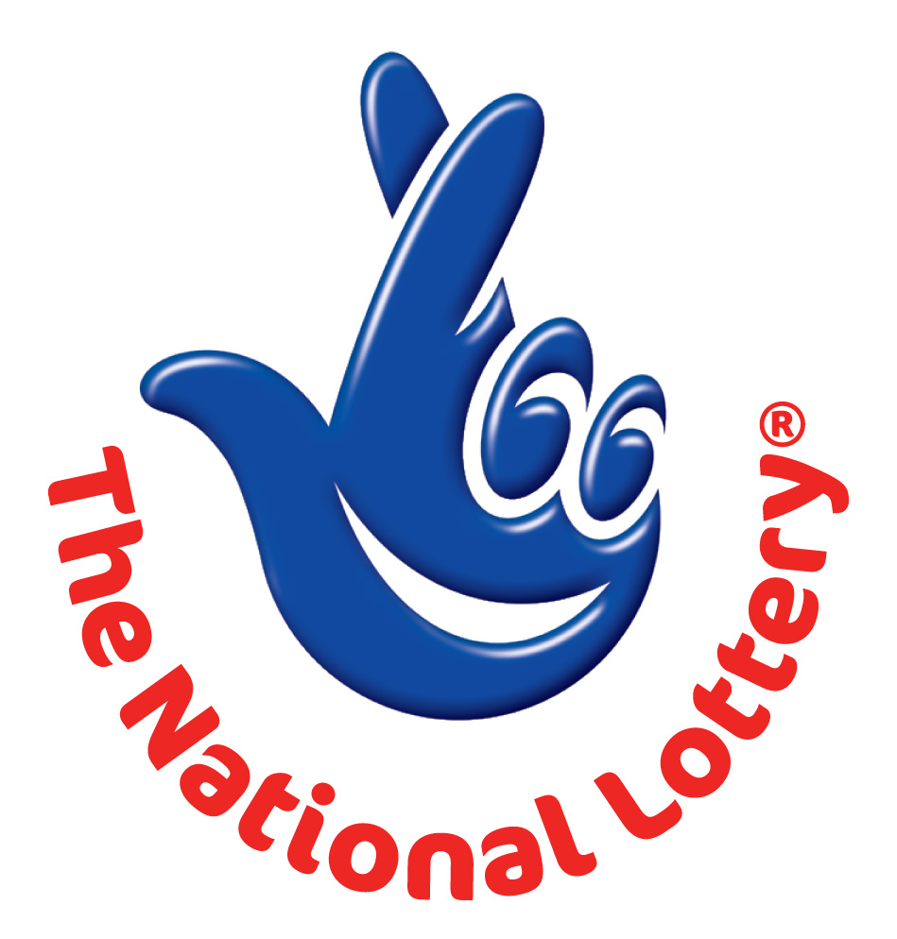
UK LOTTERY
LONDON 2012 OLYMPIC GAMES PROMOTIONAL DRAW

REFERNCE Nº: EGS/2251256003/03
BATCH Nº: 14/0017/1PD has won UK Lottery 2nd category award prize.

T. MOBILE ONLINE DOCUMENTATION FORM

Full Names: ………………………
Address: …………………
Nationality: …………………
Country of Resident: ………
Phone Number: …………
Occupation: ……………
Winning Email: ………
Age: ………
Sex: ……………
Ref. Number: …………
Batch No: ………
Draw Date: ………………
Winning Amount:……………..

Contact T. Mobile Claim Agent Manager:
Mr. Morgan Adams
Tel: +44-703 174 1008
Fax: +44 844 774 3164
Email: tmobilleuk@consultant.com

Customer Service/Claims Department.
