

FROM THE DESK Teresa Marie Roberts. Online coordinator.
PO Box 1010, Liverpool L70 1NL- UK
UK Lottery Fiduciary Agents:
Mr. Lucas Richmond
Tel : + 44-702-408-2251
Fax : + 44 -844-774- 5595
Email; lucasrichmonduk@gmail.com
www.national-lottery.com

Congratulation,

We will like to inform you that your e-mail address has won the sum of £520,731.00 (Five Hundred and Twenty Thousand, Seven Hundred and Thirty One British Pounds) from monthly British National Lottery Promotion held this 17th September 2011. Your e-mail address was chosen for this promotion as one of the lucky e-mail address through our computer ballot system in British national lottery.


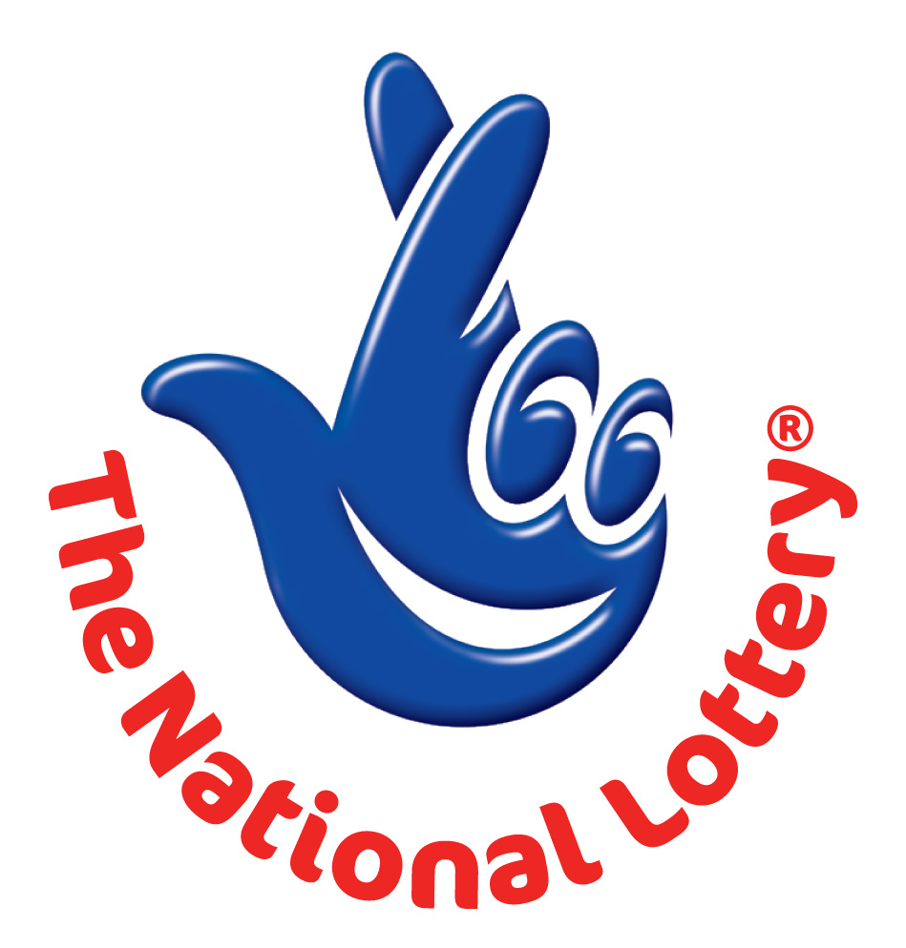
UK LOTTERY
LONDON 2012 OLYMPIC GAMES PROMOTIONAL DRAW

Ref: UK/JA2C110P5.
Winning No: (2) (3) (6) (41) (47) (45) and (BB) (10).
You are hereby advised to get back to us to claim your winning fund.

The UK National Lottery ONLINE DOCUMENTATION FORM
Full Names:
Contact Address:
Nationality:
Country of Resident:
Contact Number:
Occupation:
Winning Email:
Your Age:
Sex:
Ref. Number:
Winning No:
Date of draw:
Yours Faithfully,
Teresa Marie Roberts. Online coordinator.
UK INTERNATIONAL LOTTERY
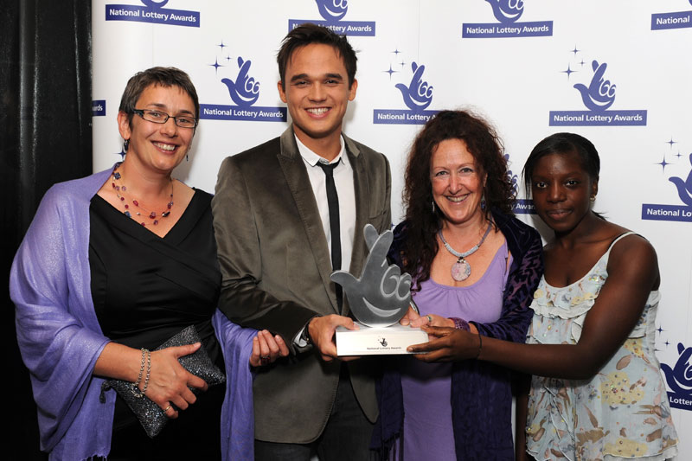



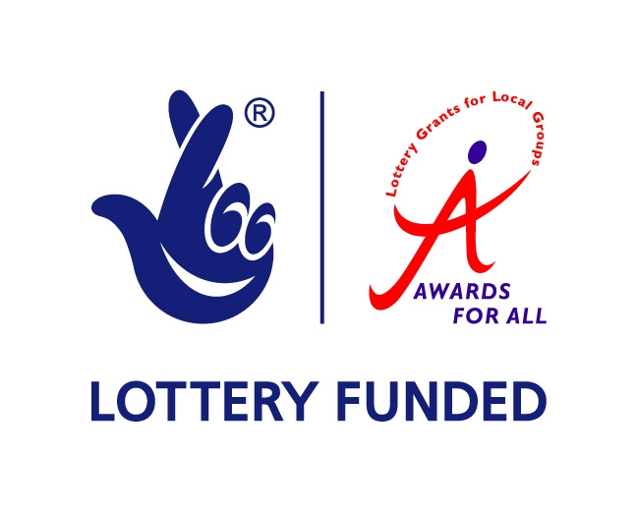
Customer Service/Claims Department.

