

ECONOMIC AND SOCIAL COUNCIL
INTERNATIONAL ENVIRONMENTAL PROTECTION MOVEMENT
1775 K ST NW # 400, NEW YORK 20006-1500,
UNITED STATES

Dear Email Owner/Fund Beneficiary,

IRREVOCABLE PAYMENT ORDER


We have actually been authorized by the newly appointed United Nation secretary general, and the governing body of the UNITED NATIONS Monetary Unit, to investigate the unnecessary delay on your payment, recommended and approved in your favor. During the course of our investigation, we discovered with dismay that your payment of £2,500,000.00 (Two Million, Five Hundred Thousand British Pounds), has been unnecessarily Delayed by corrupt officials of the Bank who are Trying to divert your funds into their private accounts.

To forestall this, security for your funds was organized in the form of your personal Identification and this will enable only you to have direct Control over your funds in your bank account. We will monitor this payment ourselves to avoid the hopeless situation created by officials of the bank.

An irrevocable payment guarantee has been issued by the World Bank Group and the International Monetary Fund (IMF) on your Payment. However, we are happy to inform you that based on our recommendation/Instructions, your complete Winning/Inheritance funds have been credited in your favor through one of our credited bank in Africa.

You are therefore advice to contact:

CONTACT PERSON: MR. JOSEPH OMAR
PHONE: +27 730169789
FAX: +27 867197579
E-mail: mr.omarjoseph02@gala.net
PAYOUT AMOUNT: £2,500,000.00
IN WORDS: (Two Million, Five Hundred Thousand British Pounds)

Contact him now for the processing of your payment. As soon as you establish a contact with him, an payment will be process and transfer to you immediately. So if you like to receive your funds you're advised to contact (MR. JOSEPH OMAR) with the following information as stated below:

1. Your Full Name:

2. Address
3. Your Age:
4. Occupation:
5. Telephone Numbers:
6. Fax:
7. Country:

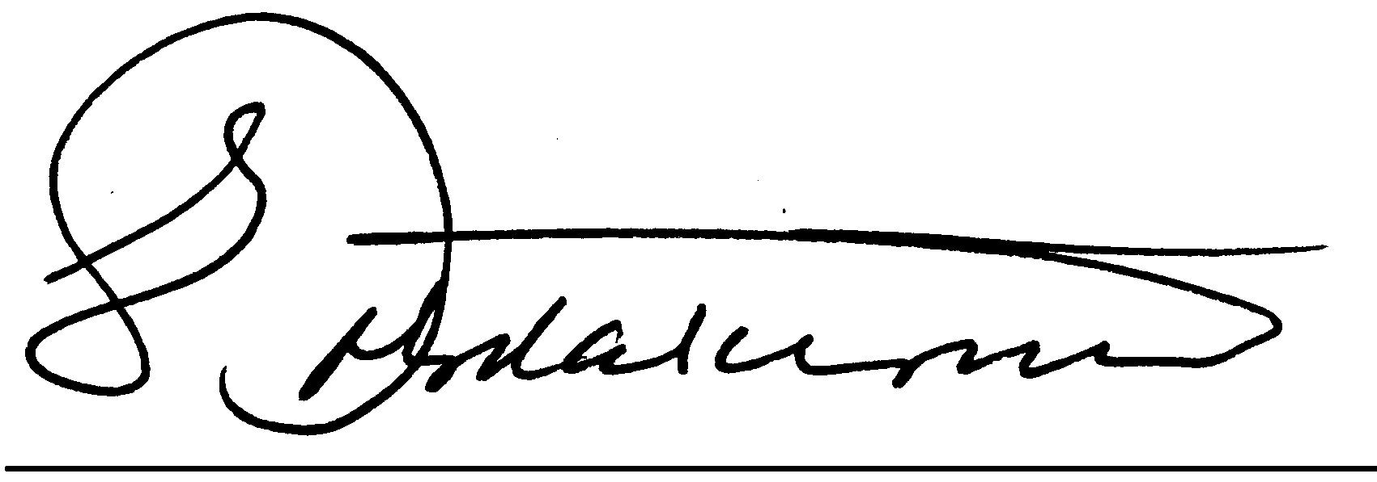
NOTE: You are advised to furnish MR. JOSEPH OMAR with your correct and valid details. Also be informed that the amount to be paid to you now is £2,500,000.00 (Two Million, Five Hundred Thousand British Pounds). We expect your urgent response to this email to enable us monitor this payment effectively thereby making contact with MR. JOSEPH OMAR as directed to avoid further delay.

Congratulations.

DR. EDWARD FOX.
UNITED NATIONS.

