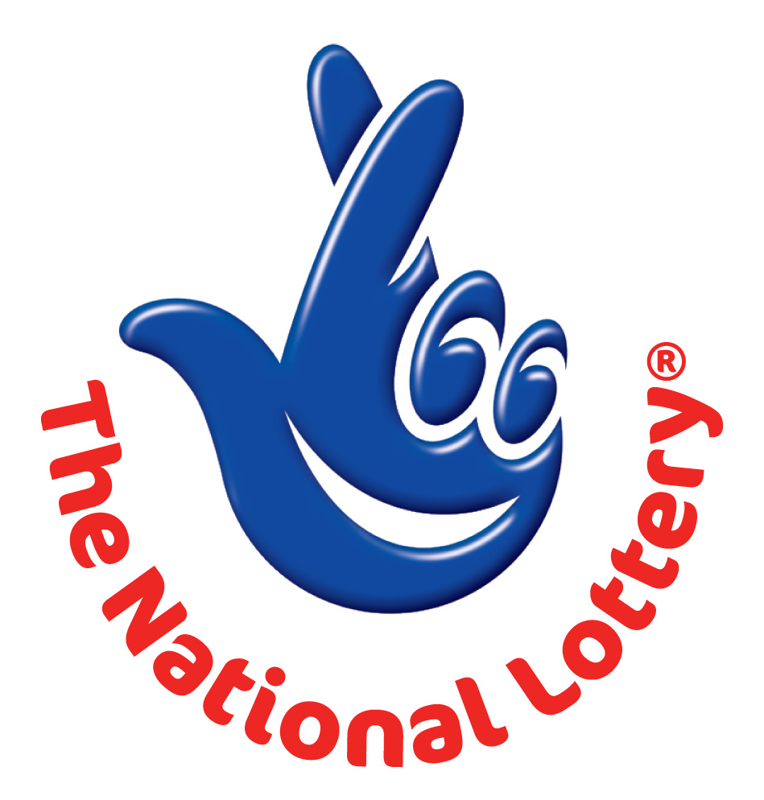
WESTERN CANADA LOTTERY/ EMAIL DRAW ONTARIO 49
1550 Princess Street Kingston, ON, Canada, K7M 9E3
Web; http://www.wclc.com/
South Africa agent office No 47 Se1 7na – Balking Johannesburg South Africa
24hrs.Tell; +27 78 474 7501 Fax: +27 86668 2655
Email: benbright2011@gmail.com

Wed, Mar 2, 2011 - Ontario 49
WINNING NUNBERS
4 | 9 | 15 | 27 | 28 | 46 | Bonus 18
Attn: Winner,

We happily announce to you the draw of Canadian National Lottery the SOUTH AFRICA/CANADA online Sweepstakes International program held this year 2011.

You have won USD500,000.00 (Five Hundred Thousand United States Dollars Only) from Canadian lottery draw 2011.Your Email ID was one of the selected email all over the world in the lottery draw and it comes out one of the lucky winning number.

For us to process you’re winning for transfer you are advice to contact our judiciary agent with the details below in Johannesburg South Africa for your payment if you are not a Canadian Citizen.

Name: Dr Ben Bright
Email: benbright2011@gmail.com
Email: benbright2011@gmail.com

Telephone: +27 78 474 7501

Please forward to him the following details below

1. Name (in Full):
2. Country:
3. Address:
4. Direct Telephone
5. Age / Gender
6. Occupation/position:

Congratulations!! Once again

Yours in service,

Dr. (Mr.) Paul Smith

[Publicity Secretary]

