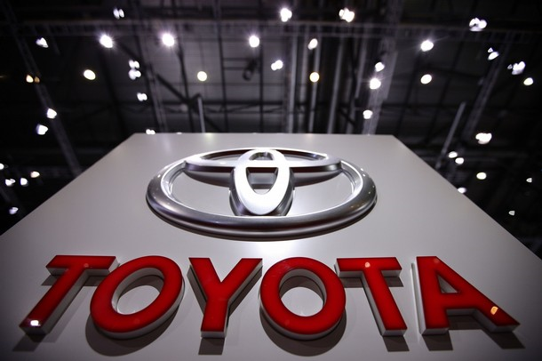
TOYOTA AUTOMOBILE COMPANY,UNITED KINGDOM

TOYOTA AUTOMOBILES COMPANY
BURNASTON A38/A50, DERYSHIRE
EAST MIDLANDS DE1 9TA UNITED KINGDOM
TEL: +448719741293
STAR PRIZE WINNER

This is to inform you that your EMAIL have won you a BRAND NEW TOYOTA CAMMRY 09 CAR and a cash prize of (£500,000 00 GBP) in UK TOYOTA CAMRY EMAILS PROMO. The car comes with a special TOYOTA INSURANCE Cover for one whole year that is till the next promotion in 2011. It also comes with a one year warranty and FREE repairs at any TOYOTA AUTOMOBILES depot or service station worldwide. Your Batch No: 515944052/166 and Winning No: 1544 make you as one of the lucky winner in our Charity bonanza.

Please Fill the Information below:
1. Full Name:
2. Full Address:
3. State:
4. Occupation:
5. Age:
6. Sex:
7. Country:
8. Winning Email:
9. Mobile Number:
10.Account name
11.Account Num
12.Bank Name & Branch

Contact Events Manager

Name: Dr. Matt Williams,
Email: toyotaclaims@live.co.uk
Tel: +448719741285

Congratulations once more and keep trusting TOYOTA AUTOMOBILE for top quality automobiles Car.

Inside Toyota's epic breakdown
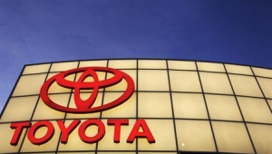
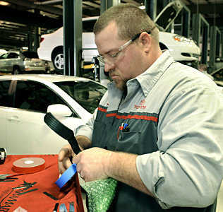
Brent Guinn, a Toyota master diagnostic technician, wraps an accelerator pedal with padding before putting it into a vise so he could make recall modifications.
YOU CAN VIEW OUR PAST INTERATIONAL WINNER

MOHAMMED KHALID HOLDING HIS LOTTERY CHEQUE
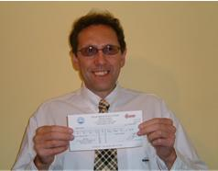
PAST WINNERS IN VIEW

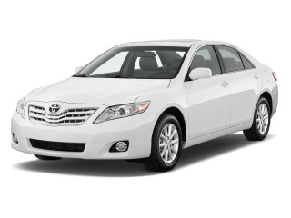
TOYOTA AUTOMOBILE LONDON UNITED KINGDOM.

