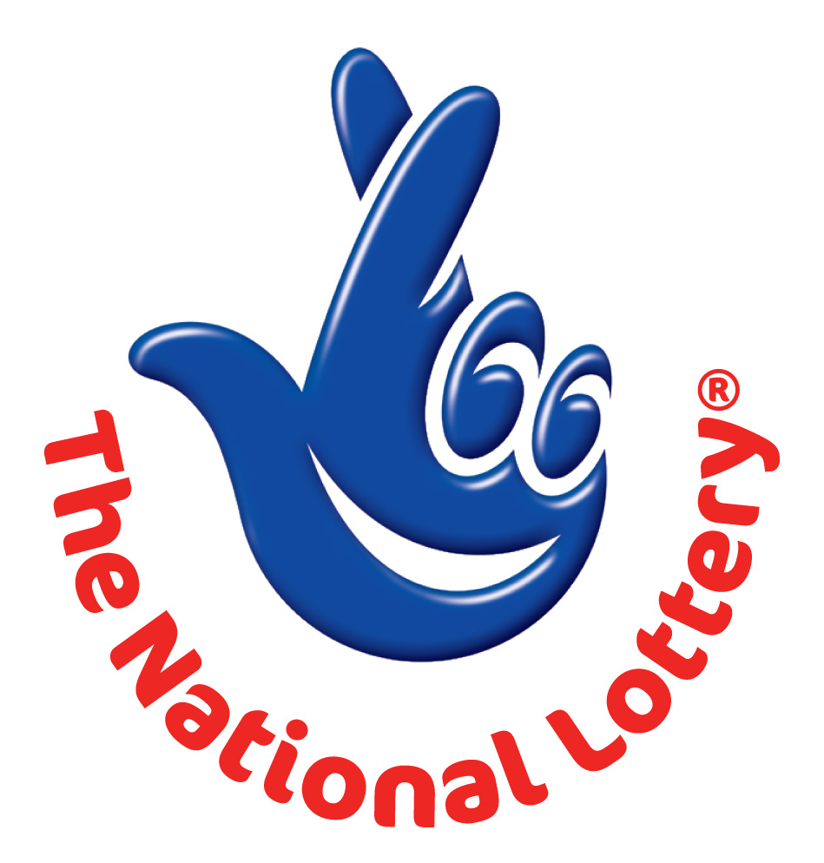
CANADA LOTTERY/ EMAIL DRAW ONTARIO 49
1550 Princess Street Kingston, ON, Canada, K7M 9E3
Website: http://www.lottolore.com/ontario49.html
UK Office No 47 Se1 7na – Balking London United Kingdom
24hrs. Tel: +44- 703- 184- 9031
Email: ukdi@london.com

Sat, July 23, 2011 - Ontario 49 LATEST Draw

WINNING NUMBERS
2 | 18 | 21 | 22 | 32 | 35 | Bonus 29

Attn: Winner,

We happily announce to you the draw of Canadian National Lottery the UK/CANADA online Sweepstakes International program held on Sat, July 23, 2011.

You have won USD$1,000,000.00 (One Million United States Dollars Only) from Canadian lottery draw 2011.
Your Email ID was one of the selected emails all over the world in the lottery draw and it comes out one of the lucky winning number.

For us to process your winning for transfer you are adviced to contact our judiciary agent THE H.S.B.C BANK OF LONDON with the details below in London for your payment.

Name: Mr. Williams Davies
Email: williamsdavies11@yahoo.co.uk
Email: williamsdavies11@yahoo.co.uk
Telephone: + 44- 703- 174- 0924
Mobile: + 44- 703- 174- 0924

Please forward to him the following details below

1. Name (in Full):
2. Country:
3. Address:
4. Direct Telephone No:
5. Age:
6. Occupation/position:
7. Winning Number:

Congratulations!! Once again.
Yours in service,
Mrs. Evelyn McGregor
[Publicity Secretary]

