CONGRATULATIONS!!!

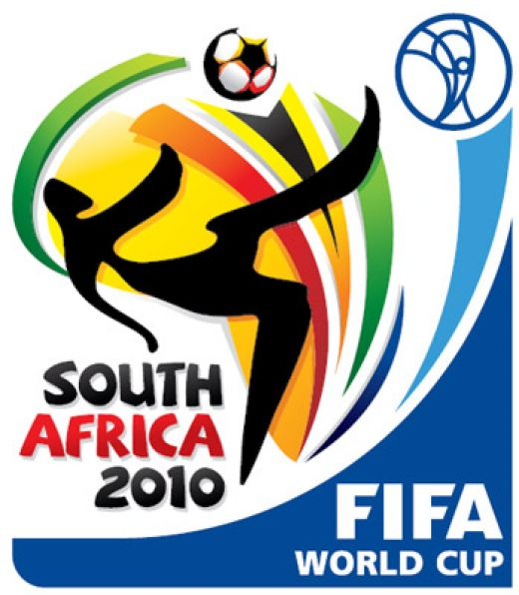
The Government of South Africa, the Federation of International Football Association (FIFA) and the South African Football Association (SAFA) in appreciation of the global support for the South Africa successful hosting of the FIFA 2010 World Cup, has recently organized an award promotion.

This award promotion is based on the selection of winners from the World Wide Web and without any limitation to email provider or country.

Winners of this award where selected randomly from millions of email addresses generated by a special software and system operated by the South Africa National Lottery & Gambling Board.

Consequently, we would like to inform you that your email address is one of the 7 email addressee owners picked by the award system and that is why we are contacting you.

You are hereby directed to confirm that you are the rightful owner of this email address and you will be contacted shortly on the receipt of your reply to receive your award prize of USD2,000,000.00 (Two Million United States Dollars)

You are requested to contact the Processing Director immediately you receive this notification with the below information, to enable him start with the processing for the release of your winning prize without any delay.

Your information required for proper identification are as follows:

Full Names:
Date of Birth:
Gender:
Contact Address:
Occupation:
Country of Origin:
Country of Residence:
Phone #:
Fax #:
Mobile Phone #:

For further information about how to receive you award winning prize contact:

THE PROCESSING DIRECTOR
MR. WHITE BROWN
TELE: +27 71 062 7801
FAX: +27 86 601 8108
EMAIL: whitebrown@hotmail.co.za
Congratulations from all of us here at the SA 2010 Fifa World Cup Organizing Committee, FIFA, SAFA and the South African Government.
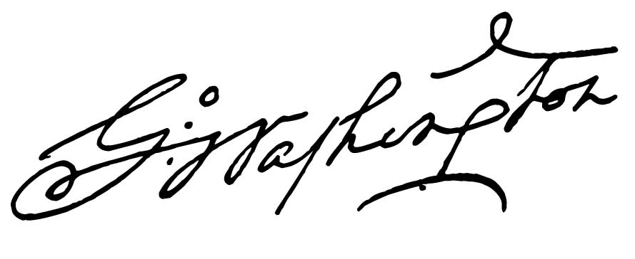
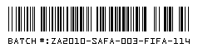
Yours Faithfully,


Mrs. Sarah Baartman

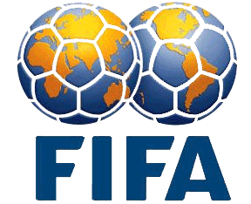

Coordinator

Sponsors :

