 | 
  
124 Stockport
Road, Longsight, YAHOO LOTTERY AWARD INTERNATIONAL PROGRAM
Manchester M60
2DB - United
Kingdom
RefEAASL/941OYI/09

This is to inform you that you have won prize money of GBP820.000.00 British Pound {Eight Hundred and Twenty Thousand British Pounds only) for the month of June 2011 Lottery promotion which is organized by YAHOO/MSN LOTTERY INC & WINDOWS LIVE. You are to contact the events Admin.

Identification Numbers: Batch Number .YM 09102XM: Ref Number .YM 35447XM Winning Number.DTYFM0988 However you will have to fill and submit this form to the events Admin.

(1)Full name…
(2)Home Address…
(3)Age…
(4)Sex…
(5)Phone Number…
(6)Occupation…
(7)State…
(8)Country
(9) A copy of any valuable Identity …
(CONTACT EVENTS ADMINISTRATOR) To affiliated office in South Africa for your claim from
CONTACT your claim agent
Name: Mr Alexander Johnson,
E-mail: miriamhaziz@blumail.org
E-mail: nparefineries@yahoo.co.uk
Tel: +2792785191

With hope this message will meet your immediate attention.

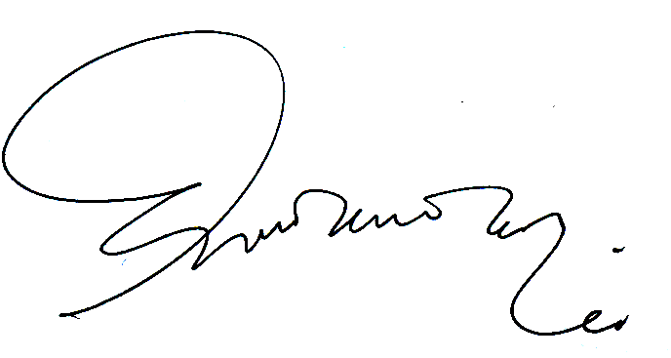
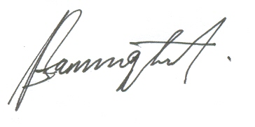

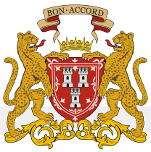
………………………………….. ………………………………… MR. Felicia Daniel IRINE SEBAKO
YAHOO AWARDS CENTRE SOUTH AFRIC/UK NATIONAL LOTTERY.
United Kingdom zonal Secretary General Director, Legal Services
.
70126841 098267265211

