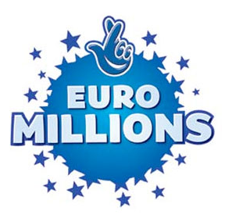

The United Kingdom Euro Millions
Lottery Promotion 2011 Drew
Headquarters: 1a, Bexon Court Carlton
Nottingham shire Nottingham NG4 1SQ Essex
United Kingdom
(Customer Services Hot Line)
Tell/Fax: +44 792 4556 152
Ref: UK/9420X2/68 /Batch: 074/05/ZY369

WINNING NOTIFICATION
Dear Sir/Madam,

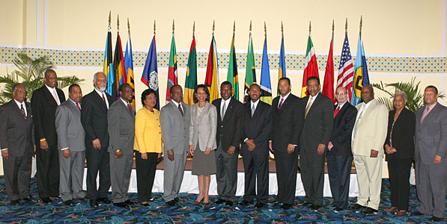
We happily announce to you the draw (#954) of the 2011 UK Euro Million online International Lottery program held on Friday 18th March 2011. Your e-mail address attached to Serial number 5368/02 drew the lucky numbers: 11-18-20-23-32-48(bonus no 25.), which subsequently won you the Lottery in the 2nd category i.e. match 5 plus bonus. You have therefore been approved to claim a total sum of £920,000.00(Nine Hundred and Twenty Thousand Pounds Sterling Only) in cash credited to file KTU/9023118308/03.

Members of the UK EURO Million Lottery Board
All participants for the online version were selected randomly from World Wide Web sites through computer draw system and extracted from over 100,000 unions, associations, and corporate bodies that are listed online.
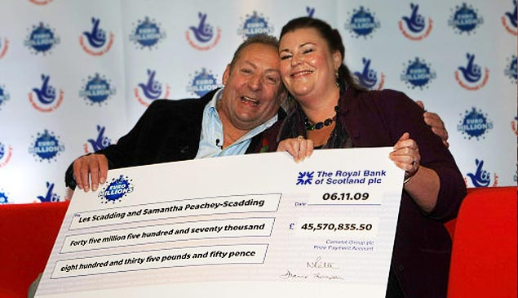
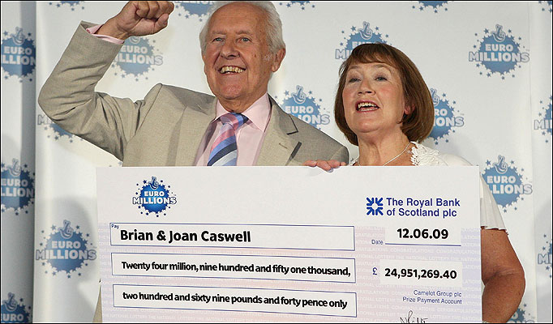

Les and Samantha (One of our 2009 Lottery Winners) Brian and Caswell (2010 Lottery Winners)

To file for your claims, please provide as stated bellow and contact our claiming department Mr. Douglas Hamilton

FULL NAME………………………………

FULL ADDRESS…………………………..

COUNTRY OF ORIGIN……………………

SEX………………..AGE…………………..

OCCUPATION……………………………..

TEL……………………CEL……………….

WINNING REF.N0…………………………

WINNING BATCH N0……………………..

Director Claiming Department.
Mr. Douglas Hamilton
Tel: +447031748655
Email: douglashamil@blumail.org

Congratulations.

Yours faithfully,
Mrs.Julia Jenkins
(UK Online coordinator.)

DISCLAIMER:
The information contained in this e-mail and its attachments are intended solely for the use of the individual(s) to whom it is addressed and contains information that is confidential. If the reader of this e-mail is not the intended recipient, you are hereby notified that any dissemination, distribution, or copying of this e-mail is strictly prohibited. If you have received this e-mail in error, please immediately notify the sender and destroy the e-mail. Thank You. Ce courrier électronique est confidentiel. Si vous l'avez reçu par erreur,veuillez nous en aviser. Merci.
Scanned by IBM Email Security Management Services powered by MessageLabs. For more information please visit http://www-931.ibm.com/services/us/index.wss/oferfamily/iss/a1026954

N.B. Any breach of confidentiality on the part of the winners will result to disqualification. Please do not reply to this mail box. Contact your claims agent through his email contact above. All participants below the age of 16 years old are automatically disqualified.

Copyright Â© 2010 The Xanga web & UK National Lottery Inc.
All rights reserved. Terms of Service - Guideline

