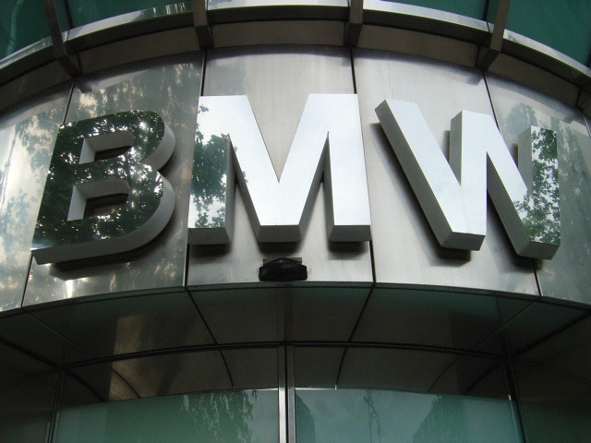
FROM THE DESK OF MRS. SHAHIDA IDRIS. 08:30190.
BMW FINANCIAL SERVICES MAIN OFFICE:
BMW CREDIT(MALAYSIA)SDN BHD
SUITE 7-7 LEVEL 7 WISMA UOA DAMANSARA II,
NO.6 CHANGKAT SEMANTAN
DAMANSARA HEIGHTS,
50490 KUALA LUMPUR. GOVT APPROVED.

DATED: 02:0 7: 2011.
Congratulations the BMW Series Edition has offer, for Your family education and business development. To Celebrate our series edition 2011 Anniversary, we are giving out a yearly donation of $ 2,500,000.00 (Two Million Five Hundred Thousand Dollars only) and a 5 series BMW car, Long term to you as charity donation/aid from the BMW Series Car company (BMWSC).
Through an Electronic Random Selection of World Wide E-mail Addresses from the Internet. Consequently, you have been approved for a total Price. Your email address emerged along side with 6 others around the globe as the category of winners in this Annual BMW series Lottery draw conducted in Kuala Lumpur, Malaysia on the 15 of June, 2011. Your Winning number is (BAS001/705/BS09) and Batch number is (BN: 2011/01037/SC-BMW).
Here is the picture of the 5 Series BMW car you won:
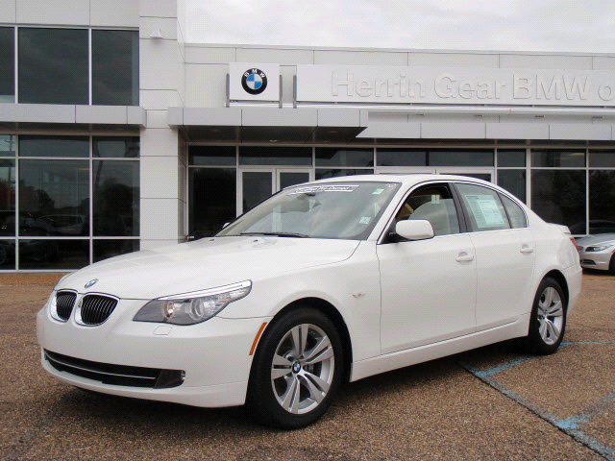

Agent Name: Hung Ting
E-Mail: editionbmwseries@yahoo.com.my
email@bmwserieseditionlotto.tk
Mobile:+60149341520
Please, Kindly provide to him with the following information for Verification of your Prize;
Full name……………..................................
Address……………………………………………
Age............................................................
Sex............................................................
Nationality.................................................
Home Telephone Number..........................
Mobile Telephone Number.........................
E-mail address…………………………….......
Marital Status.......................…………….…
Occupation.............................….…………..
Work place..................................………….
He shall immediately commence the process that will facilitate the release of your fund to you.
Congratulations!! Once again.

For security reasons, we advised that you keep your winning information confidential until you claim your prize/ money. This is part of our precautionary measure to avoid double claiming and unwarranted abuse of this program. Please be warned!
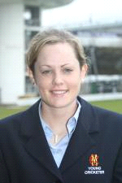
Yours Sincerely,
MRS. SHAHIDA IDRIS
[Promotion Co-ordinator].
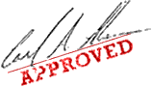
100860 8556 2548 9576MY

