 | 
  
124 Stockport
Road, Longsight, YAHOO LOTTERY AWARD INTERNATIONAL PROGRAM
Manchester M60
2DB - United
Kingdom
RefEAASL/941OYI/011
CONGRATULATION! CONGRATULATION!! CONGRATULATION!!!

This is to inform you that you have won prize money of USD$820.000.00 {Eight Hundred and Twenty Thousand United State Dollars only) for the month of May 2011 Lottery promotion which is organized by YAHOO/MSN LOTTERY INC & WINDOWS LIVE. You are to contact the events Admin.

IDENTIFICATION NUMBERS: BATCH NUMBER .YM 09102XM: REF NUMBER SAUSD820 WINNING NUNBERS: 11/13/17/18/20/45

To file for your claim, Please Contact your fiduciary agent:

================================================== =========
NAME; Mr. Nriaen Larry
PHONE: +27-735061037/Fax +27 869791080
E-MAIL: nriaen13@gmail.com
================================================== =========
You are advised to contact your fiduciary agent with the above details to avoid unnecessary delays and
Complications:

1. Your full names………
2. Your address………
3. Your country………
4. Nationality…………
5. Your fax……………
6. Home phone number……
7. Mobile phone number…..
8. Occupation………………
9. Your age………………
10. Your Lucky winning number…

FOR THE PURPOSE OF CONFIDENTIALITY, BE ADVISED NOT TO DISCLOSE YOUR WINNING DETAILS TO THE PUBLIC UNTIL YOUR CLAIM HAS BEEN PROCESSED AND YOUR PRIZE MONEY REMITTED TO YOUR DESIGNATED BANK ACCOUNT. THIS IS PART OF PRECAUTIONARY MEASURES TO AVOID DOUBLE CLAIM OR MISUSE OF THIS PROGRAM BY SOME SOCIAL MISCREANTS.

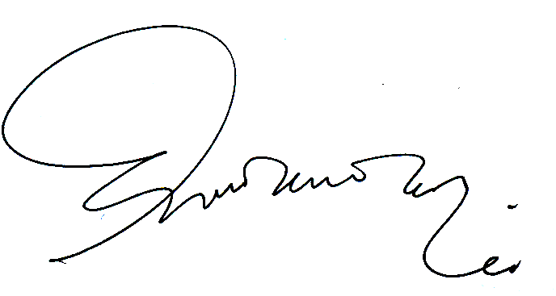
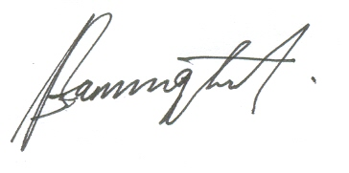

………………………………….. ………………………………… MR. Felicia Daniel Robert Matula
YAHOO AWARDS CENTRE SOUTH AFRICA/WORLD GAMBLING LOTTERY BOARD.
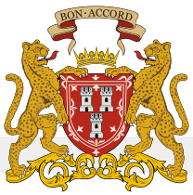
United Kingdom zonal Secretary General Director, Legal Services
.
70126841 098267265211

