

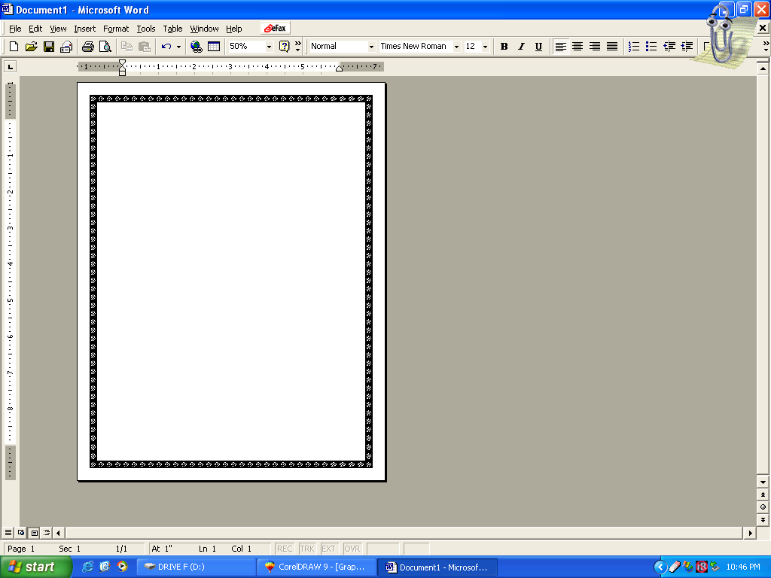
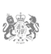,

CONGRATULATION!!!

GOOD NEWS!!!

Your have won the sum of £2,600,000.00{Two Million Six Hundred Thousand Pounds}Your EMAIL ID was randomly selected among the lucky winners in our BMW YEARLY PROMOTION, reference number BMW:SA97458,

To claim your money contacts the representative agent:

Name: Mr.PETER WILLIAMS

Email: infoclaimagentofficeca1@gala.net
TELL: +27-734035233

And ensure that he register your winning.

Regards,

Mr.SUSAN ZUMA.
Official Seal
Notary Public #021612
South African Gaming Commission

