
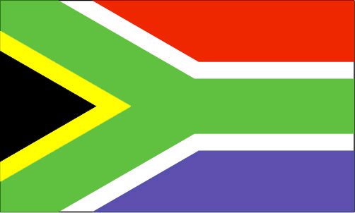
British South African 2011 Online Lottery 2011
Special Winning Notification

This is to notify you that your Email ID has lucky won the sum of Five Hundred Thousand British Pounds (£500,000.00) in the British-South African 2011 Online Lottery Draw held here in London during the 2010 fifa world cup in South Africa. Note: ALL Participants in this Lottery Program have been selected randomly through a computer ballot system drawn from over 10,000,000 individuals and 5,000,000 companies email addresses from all search engines and web sites globally. This program is being sponsored by the FIFA SUPPORT AFRICAN TEAM and other Multi-National Companies around the world to thank the entire world on the successful hosting of 2010 FIFA world Cup Finals in Republic of South Africa. The sponsors want the world to partake in this greatest sporting event on Earth.

To file for your Claim, kindly call our Processing Director Mr. Tony Scott (+44 7924 586 179) E-mail: britishsouthafricanonline@gmail.com and furnish him with: 1.Full Name: 2. Present Address: 3. Country: 4. Date of Birth: 5. Occupation: 6. Mobile: 7.Sex: 8.Marital Status: 9. Reference No: B-SA/2010/00XB/EFC/10: 10.Batch No: 34526770/060001. 11. Winning Numbers: 01, 05, 28, 33, 44, 46 and Bonus 07

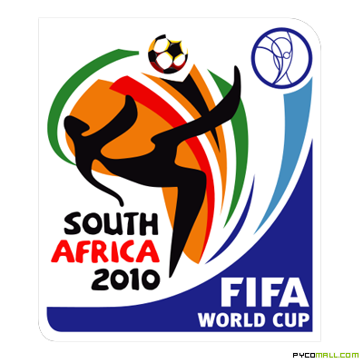
He will be able to know through your reference/batch numbers to ascertain if your payment falls on either our UK London Payment Centre or South African Payment Centre.

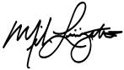
Yours faithfully.

Dr. Johnson Spencer (Zonal Coordinator)

