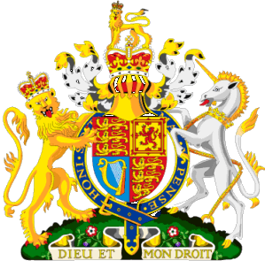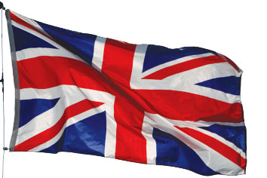
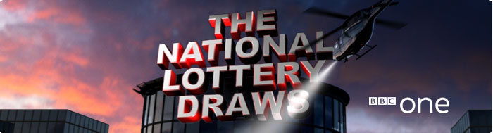
BBC One National Lottery Team
National Lottery Draws Results.
Po Box 200, Harrogate England, United Kingdom.
BBC One Lottery Representative
Tel: +44-7017917131
Fax: +44-7017936549
E-mail Address: bbc.one.lottrey.claims.dept.u.k@hotmail.co.uk
Visit Our Web Site www.bbc.co.uk/lottery/

Draw No: 1589
- Bonus No: 21hbjlgfj9WRRJSLFLZ
GOOD DAY SAHL; AFL [DDSG; P

G; L

JLSHGLG NO.1589 (02) (15) (16) (18) (47) (48) BONUS (21).
This is to inform you that you have WON the sum of (£450.000.00) Great British Pounds from our 2011 charity bonanza. The draw no.1589 brought out your e-mail address from a Data Base of Internet Email Users and qualified you a benefited winner of the stated winning amount, in the ongoing £44.4million Spring lottery charity bonanza for London's heritage,
Held on the 18th of March, 2011. The BBC One National Lottery Fund gives grants to sustain and transform individual lives’ all over the globe for the less privilege once; we are here to use our diverse heritage to change lives in every part of the World.
Please Fill the Information below and Send To:
( bbc.one.lottrey.claims.dept.u.k@hotmail.co.uk)
A Scan copy of your Identification (Driving License or any Valid I.D Proof) is needed.
1. Full Name:
2.Full Address:
3.State:
4.Occupation:
5.Age:
6.Sex:
7.Country:
8. Email:
9.Tel.Number:
10. Next Of Kin:

Yours sincerely
Dr. J.T WALTER
Tel: +44-7017917131
Fax: +44-7017936549

Visit Our Web Site www.bbc.co.uk/lottery/

Your Online Coordinator
Dr. J.T WALTER,
The online coordinator, B.B.C One Department,
National Lottery Results England

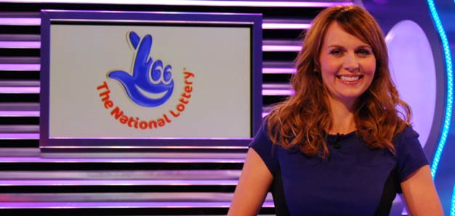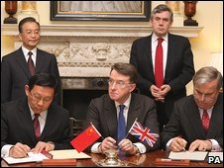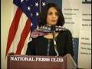
LOTTERY SPONSORS:



Friday 18th March 2011

The National Lottery Friday Night Draws presented by Dr.J.T WALTER with Thunder ball and Lotto draws, 10.35pm on BBC One.

