THE ADIDAS SEASONAL PROMOTION PRIZE AWARDS WINNING NOTIFICATION.

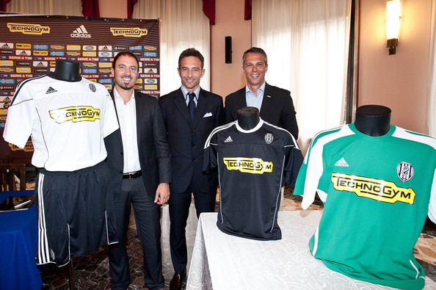

 WINNERS ONLY
A/ 94 AVENUE OPP CHURCH ROAD
LONDON; WORLD WIDE UK.
REF: ADASC/9499OK6/393/ADCP
BATCH: 7/20/0055

Dear Lucky Winner,

We are pleased to inform you of the result of the just concluded annual final draws of Adidas Annual Promo.

The online Adidas united kingdom Annual Promo draws was conducted by a random selection of email addresses from an exclusive list of 26,033 E-mail addresses of individuals and corporate bodies picked by an advanced automated random computer search from the internet. However, no tickets were sold but all email addresses were assigned to different ticket numbers for representation and privacy.

After this automated computer ballot, your e-mail address emerged as one of twelve winners in the fourth category for the second prize with the following data:

Ref Number: ADASC/9499OK6/393/ADCP
Batch Number: 7/20/0055
Ticket Number: 025-110003847-110

You as well as the other winners are therefore to receive a cash prize of 690,000.00 GBP (SIX HUNDRED AND NINETY THOUSAND GREAT BRITAIN POUNDS STERLINGS ONLY) each from the total payout. Your prize award has been insured with your e-mail address and will be transferred to you upon meeting the requirements, statutory obligations, verifications, validations and satisfactory report.
To begin the claims processing of your prize winnings you are advised to contact our licensed and accredited claims bank
for SECOND category winners with the information below: You are also advised to give the following information’s to the claim's bank via email

1. Full name and address:
2. Country:
3. Tel and fax number:
4. Occupation:
5. Your Reference and Batch number at the top of this mail:
Ref Number: ADASC/9499OK6/393/ADCP
Batch Number: 7/20/0055
Ticket Number: 025-110003847 -110
6. Age:
7. Amount won:
8 Sex:
9 your wining email address:
MR. FESAMA JIM
Transfer Director Manager HSBC international banking UK
Email: mr.fesama_jim@live.com
Phone: +44- 7014237967

NOTE: All winnings must be claimed within 10days from today. After this date all unclaimed funds would be included in the next stake.
Remember to quote your reference information in all correspondence with your claims bank.
You are to keep all lotto information away from the general public especially your reference and ticket numbers. (This is important as a
case of double claims will not be entertained).

Members of the affiliate agencies are automatically not allowed to participate in this program. Promo Customers Service: +44- 7014237967

Time: 10.00am to 2 .00pm G.M.T

Thank you and congratulations!!!
Yours faithfully,
Maxwell Bush
Managing Director Adidas.
Copyright © 2011 Adidas.

