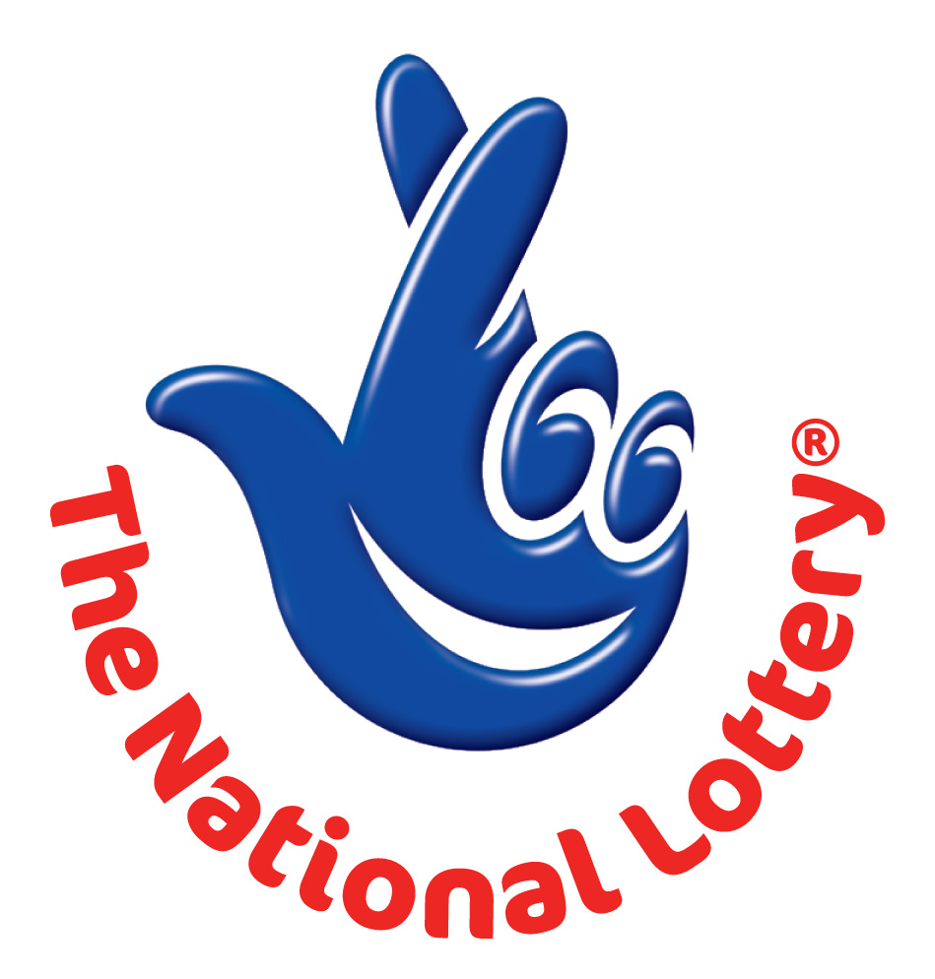
WESTERN CANADA LOTTERY/ EMAIL DRAW ONTARIO 49
1550 Princess Street Kingston, ON, Canada, K7M 9E3
Web; http://www.wclc.com/
UK Office No 47 Se1 7na – Balking London United Kingdom
24hrs.Tell; +44 703 174 7380 Fax: +44 844 774 5941
Email:aarongray@gala.net

Sat, Feb 19, 2011 - Ontario 49
WINNING NUNBERS
10 | 16 | 20 | 26 | 34 | 48 | Bonus 40
Attn: Winner,

We happily announce to you the draw of Canadian National Lottery the UK/CANADA online Sweepstakes International program held this year 2011.

You have won USD 1,000,000.00 (One Million United States Dollars Only) from Canadian lottery draw 2011.Your Email ID was one of the selected email all over the world in the lottery draw and it comes out one of the lucky winning number.

For us to process your winning for transfer you are advice to contact our judiciary agent with the details below in London for your payment.

Name: AARON GRAY
Email: aarongray@gala.net
Email: aarongray@gala.net

Telephone: +44 703 174 7380

Please forward to him the following details below

1. Name (in Full):
2. Country:
3. Address:
4. Direct Telephone No:
5. Age:
6. Occupation/position:

Congratulations!! Once again.

Yours in service,
Dr. (Mr.) Paul Smith.
[Publicity Secretary]

