


British National Lottery Headquarters.
61-70 Southampton Row United Kingdom.
Customer Service/Claims Department.
Tel: +44-702-408-5699
Fax: +44-844-774-1504

Congratulation
We, the Board and Management of British National lottery are pleased to inform you of the result of our annual Free lotto® e-base email lotto draw for 2011. The Free lotto® e-base lotto draw 2011 was conducted from an exclusive list of £1,300.000.00 e-mail addresses of individuals and corporate bodies obtained from our top 9 donors and were sorted by an advanced automated random computer ballot system. No entries were made and no tickets were sold.


Your e-mail address emerged a winner of £1,300.000.00 in the "MEGA HIT “category; hence you will be required to redeem your winning prize in South Africa (RSA) with the
Following winning information.

Ref: UK/9420X2/68.
Winning No: (27) (43) (13) (47) (40) (41).
Please contact your certified and accredited Fiduciary agent for the Claims of your lottery prize on the information provided below:
Contact Person: Dr. David Walter
E-mail: officeinfo20@gala.net
Direct Contact: Tel: +27735805762
Direct Contact: Fax: +27866194018
You are advice to provide him with the following information:
1. Full Name.....................
2. Country.......................
3. Current Contact Address.......
4. Telephone Number..............
5. Fax Number....................
6. Occupation....................
7. Age...........................
8. Sex...........................

N/B: Remember to quote your reference information in all correspondence. You are to keep all winning information confidential, especially your promo and Batch numbers. This is important, to avoid double claims. Should there be any change of address, please do inform your fiduciary agent as soon as possible.

Congratulations once more from our staffs and the entire promo board members.

Yours Faithfully,
Dr. David Walter
Processing Director
Direct Contact Tel: +27735805762
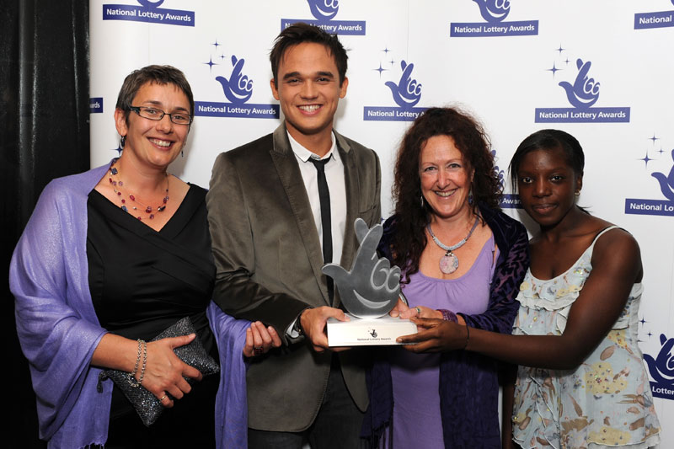
Direct Contact Fax: +27866194018

