
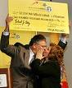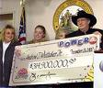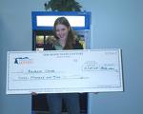
BONUS
Universal Networks Company.
Charnham Lane, Hungerford, Berkshire, RG17 0EY
UNITED KINGDOM
(Customer Services)

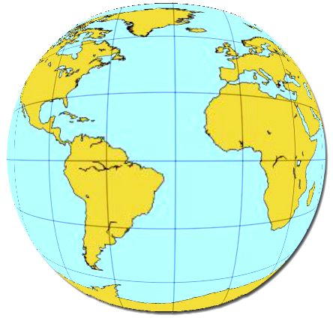

REF NO: UNWC
BATCH NO: 45UNWC
LUCKY NO: 65700

MIDDLE EAST AND UNITED KINGDOM INTERNATIONAL LOTTERY FOR WORLD INTERNET USERS, PROMOTION OF 2011,
FROM DESK OF PROMOTION {UNIVERSAL AWARD EMAIL LOTTERY}
YOUR EMAIL ID HAS WON £ 1,500,000 (One Million Five hundred Thousand British Pounds sterling.) in the first category of our computer ballot email lottery.

This promotion is for our newly formed company to gain popularity in the Global Email Networking, the selection process was carried out through random selections in our computerized Email Addresses election system from a database of over 250,000 Email Addresses drawn from all the continent of the world.

This promotion is approved by the British Gaming Board and also licensed by the international association of gaming regulators (IAGR) and we are proud to say that over 7 MILLION BRITISH POUNDS STERLING are won in more than 10 countries worldwide and all winning must be claimed as soon as possible to avoid delay.

So as one of the winners, your winning prize will be process and you receive your prize, but to enable us to process your prize, you are requested to fill the form below completely and send to us with a copy of your international passport or National ID Card.

As soon as you fill the form and return back to us by email attachment, we shall process your prize and inform you how you will receive your winning prize and also one of the rule of this promotion is that after you receive your money, you will be invited to visit us for the ceremony in London for all the 5 winners and we shall use the ceremony to appoint all the winners to represent this management in each of the countries.

BBC & CNN will be there to interview all of our winners and it will be our great honor to have all the winners on the ceremony day.
We await your immediate reply.
No ticket was sold but it is to encourage the use of Internet and to claim your winning prize contact the paying agent office:
Send the following to the claim department: All winnings must be claimed not later than 20 days. Note winners under 18 years are automatically disqualified
Dr. Michael Harrison (International Claims Agent, universal Award Email Lottery
Fiduciary)
Telephone: +447045713269
Email: williamsroselyn40@yahoo.com

DATA/PRIZE RELEASE APPLICATION FORM:

1) APPLICANT’S NAME:

2) CONTACT ADDRESS:

3) TELEPHONE NUMBER:

4) AMOUNT WON:

5) OCCUPATION:

6) AGE:

7) SEX:

8) MARITAL STATUS:

9) NATIONALITY:

10) WINNING EMAIL:

11) STATE:

12) COUNTRY:

13) ATTACH COPY OF YOUR INTERNATIONAL PASSPORT OR YOUR INDENTITY CARD. :

14) PASSPORT OR YOUR ID CARD NUMBER;

Warning: You are expected to keep information relating to your award private until payment is processed and received, this is to avoid having your mailbox hacked by any of the persons to whom you disclosed it and using the information obtained to attempt to impersonate you and to fraudulently collect your award fund.Contoversial claim will lead to disqualification. Be warned! .

Mrs. Roselyn M. Williams. (Lottery Coordinator)
Online coordinator for Universal
Mrs. Roselyn M. Williams


.

