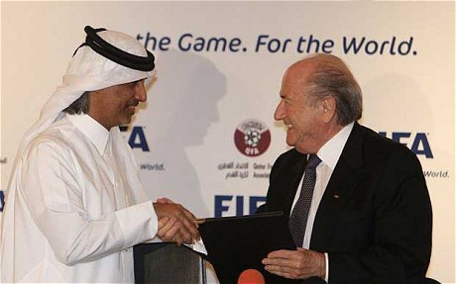
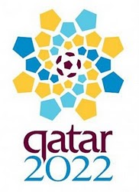

QATAR WORLD CUP AWARD VERIFICATION FORM.
This is to inform you that you have won a prize money of Seven Hundred and Twenty Thousand Pounds (£720,000.00.) for the month of February/April 2011, Prize promotion which is organized by Qatar 2022 Bid Campaign Award Promotion collects all the emails of the people that are active online, among the millions that use emails and few from other service providers. Six people are selected monthly to benefit from this promotion and you are one of the Selected Winners.
PAYMENT OF PRIZE AND CLAIM
Winners shall be paid in accordance with his/her Settlement Center. Fifa Prize Award must be claimed no later than 15 days from date of Draw Notification. Any prize not claimed within this period will be forfeited. Stated below are your identification numbers:
BATCH NUMBER: 2022 Qafi22/Unfoq
REFERENCE NUMBER: 2022UK68
These numbers fall within the England Location file, you are requested to contact our fiduciary agent in London and send your winning identification numbers to him; below you will find a Documentation Form, requesting you're required particulars.
FULL NAMES: ________________________________________________________________________
ADDRESS: __________________________________________________________________________ ___________________________________________________________________________
PHONE:/FAX_________________________________________________________________AGE: ___________________________________________________________________________CCUPATION: ______________________________________________________________________
NATIONALITY________________________________________________________________E-MAIL ADDRESS: ____________________________________________________________________
You are required to be above 18 years of Age to be able to Claim this Award. Do fill and submit the above particulars to The United Kingdom Payment Office.
Overseas Claims/Exchange Online Payment Unit
Contact Person: Name: Denny Robert
Tel/Fax: +44 870 974 0462
Email:denny@qatar.io
CONGRATULATIONS!!!
Yours faithfully,
Dr.Davis Williams, Qatar Online Coordinator.
Qatar Online Award Worldwide Copyright (c) 1994-2011. Inc
All rights reserved. Terms of Service -Guideline. 77635 476378 255667460.
----------------------------------------------------------------------------------------------------------------------------------------------------
WARNING!
Do not tell people about your Prize Award until your money is successful handed over to you to avoid disqualification that may arise from double claim. You may also receive similar e-mails from people portraying to be other Organizations or Mobile Inc. This is solely to collect your personal information from you and lay claim over your winning.

