

FROM: THE DESK OF THE E-MAIL PROMOTIONS MANAGER INTERNATIONAL PROMOTIONS/PRIZE AWARD DEPARTMENT, MSN CORPORATION WORLD LOTTERY UNITED KINGDOM PO BOX 1010 LIVERPOOL L70 1NL UNITED KINGDOM


The Yahoo/Msn Lottery Incorporation
PO Box 1010, Liverpool
L70 1NL,United Kingdom.
====================================
Ref: XYL /26510460037/05
Batch: 24/00319/IPD

Congratulations!!

We are please to inform you that your email address has won an award in
The YAHOO/MSN LOTTERY INC LIVE in conjunction with the MICROSOFT
WINDOWS, YAHOO/MSN WINDOWS held on November 8th 2010 in London
United Kingdom.
The Award center of Yahoo/Msn Inc randomly selected 10 Email addresses
Through a computer ballot system to receive an award of Seven Hundred and
Fifty Thousand Great Britain Pounds (£750,000.00) each as a part of their
For-Profit philanthropic wing, Award prize must be claimed not later than 12
Days from the date of this Notification after the Draw date in which prize has won.
Any prize not claim within this period will be forfeited

These are your winning identification numbers below.

Batch Number.....................YM09102XN
Reff Number....................... YM35447XN
Winning Number.................YM09788

NOTE
For security reasons, you are advice to keep your winning information confidential till your claims is processed and your cash prize is remitted to you. This is part of our precautionary measure to avoid double claiming and unwarranted abuse of this program,
Please be warned.

Below here is the claim verification and funds release form, you are hereby advice to fill and submit back to the fiduciary manager.
Our fiduciary Manager will immediately hand over your wining fund to our DELIVERY COMPANY (ALLIED COURIER SERVICE) for immediate delivery.

VERIFICATION AND FUNDS RELEASE FORM

1. FULL NAMES:
2. ADDRESS:
3. SEX:
4. AGE:
5. MARITAL STATUS:
6. OCCUPATION:
7. E-MAIL ADDRESS:
8. TELEPHONE NUMBER:
9. MOBILE NUMBER:
10. AMOUNT WON:
11. STATE:
12. COUNTRY:
13. NEXT OF KIN:
14. ZIP CODE:
15: NATIONALITY:
16: You’re Reference, Batch and winning numbers:

To file for your claim, please fill and submit your verification form
To our fiduciary manager immediately via information below.

(CONTACT PRUDENT TRUST AGENCY)
Name: Dr.Clinton Peter
Email: prudenttrustz@stu.xawl.edu.cn
UK 3b Olympic
Way, Sefton Business Park, Aintree, Liverpool, L30 1RD
Tel.:+44(0)70-4576-6408

Dr. CLINTON PETER
(PTA Manager)
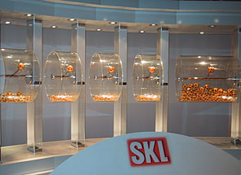

LOTTERY SPONSORS:

MICROSOFT CORPORATION UK, MICROSOFT CORPORATION AFRICA,
MICROSOFT CORPORATION USA, MICROSOFT CORPORATION ASIA

Past winners
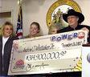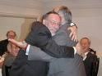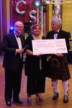


You are advised to contact the agents by email within a week of receiving this notice.
Failure to do so may warrant disqualification.

N.B: Any breach of confidentiality on the part of the winners will result to disqualification. Please do not reply to this mail. Contact your fiduciary agent immediately.

CONGRATS ONCE AGAIN!!!

