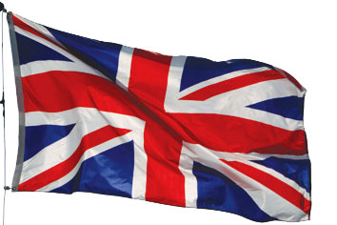

FROM: THE DESK OF THE E-MAIL PROMOTIONS MANAGER INTERNATIONAL PROMOTIONS/PRIZE AWARD DEPARTMENT, MICROSOFT CORPORATION WORLD LOTTERY UNITED KINGDOM.61-70 SOUTHAMPTON ROW BLOOMSBURY LONDON UNITED KINGDOM WC1B 4AR.

REFERENCE NO: 875061725/07
BATCH NO: 505649092/188
WINNING NO: PB8701/LPRC
WINNER: NO17
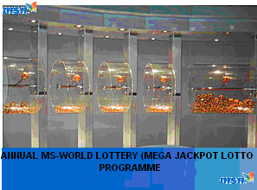
ELECTRONIC EMAIL AWARD WINNING NOTIFICATION AWARD PRESENTATION CENTER: UNITED KINGDOM

DEAR WINNER,

MICROSOFT CO-OPERATION MANAGEMENT WORLDWIDE ARE PLEASED TO INFORM YOU THAT YOU ARE A WINNER OF OUR ANNUAL MS-WORLD LOTTERY (MEGA JACKPOT LOTTO PROGRAMME) CONDUCTED ON: 3 TH OF AUGUST 2010

YOUR PERSONAL E-MAIL ADDRESS OR COMPANY EMAIL WAS ATTACHED TO THIS YEAR’S MSWLL. WITH SERIAL NUMBER 7741137002 DREW THE LUCKY NUMBERS 5-13-33-37-42, AND CONSEQUENTLY WON IN THE FIRST LOTTERY CATEGORY. YOU HAVE THEREFORE BEEN APPROVED FOR LUMP SUMS OF $ 1,000,000 (USD ONE MILLION UNITED STATES DOLLARS) PAYABLE IN CASH CREDITED TO FILE REF NO: ILP/HW 875061725/07 THIS IS FROM TOTAL PRIZE MONEY OF $ 25,000,000 USD, SHARED AMONG THE TWENTY-FIVE (25) LUCKY INTERNATIONAL WINNERS IN FIRST AND SECOND CATEGORY.

ALL PARTICIPANTS WERE SELECTED FROM WORLDWIDE A COMPUTER BALLOTING SYSTEM THROUGH OUR MICROSOFT COMPUTER BALLOT SYSTEM DRAWN FROM 21,000 NAMES, 3,000 NAMES FROM EACH CONTINENT (CANADA, ASIA, AUSTRALIA, UNITED STATE, EUROPE, MIDDLE EAST, AFRICA AND OCEANIA, AS PART OF INTERNATIONAL "E-MAIL" PROMOTIONS PROGRAMME, WHICH IS CONDUCTED ANNUALLY FOR OUR PROMINENT MS -WORD USERS ALL OVER THE WORLD TO ENCOURAGE THE USE OF INTERNET AND COMPUTERS WORLDWIDE.

YOUR FUND (CERTIFIED CHEQUE) HAS BEEN INSURED WITH YOUR REF NO: ILP/HW-475061725/07 AND WILL BE READY FOR TRANSFER AS SOON AS YOU CONTACT YOUR CLAIM AGENT DR SMITH WALKER . YOUR E-MAIL ADDRESS SHOULD BE USED IN ALL CORRESPONDENCE WITH YOUR CLAIMS OFFICER, PLEASE NOTE THAT, YOU ARE TO CONTACT YOUR CLAIMS OFFICER VIA EMAIL OR TELEPHONE AS WE ARE PROMOTING THE USE OF E-MAIL. ALSO YOU HAVE THE RIGHT TO CALL HIM TO CONFIRM YOUR WINNINGS AND GOVERNMENT TAX PAYMENT THAT IS ALL, AS HE WILL PROVIDE YOU WITH THE NECESSARY DETAILS ON HOW TO CLAIM YOUR PRIZE. AS PART OF OUR SECURITY PROTOCOL YOU ARE TO QUOTE THIS SECURITY CODE MSW/MAY/XX07 TO YOUR CLAIMING AGENT. THIS IS TO PREVENT SCAM.

CONTACT YOUR CLAIMS AGENT OFFICER IN UNITED KINGDOM.
Name: Dr. Smith Walker
Email: claims.agentsmithw@att.net
Tel: +44(0)7024041728

NOTE: IN ORDER TO AVOID MISTAKES, PLEASE REMEMBER TO QUOTE YOUR REFERENCE AND BATCH NUMBERS AND YOUR SECURITY CODE OF MSW/MAY/XX07 IN ALL CORRESPONDENCES WITH YOUR CLAIMS OFFICER. DO NOT REPLY ANY OTHER MAILS LIKE THIS ON NET, AS THEY ARE A LOT OF SCAM ARTIST OUT THERE PRETENDING TO BE US.YOU MAY SEE MAILS LIKE THIS DO NOT REPLY. DO CONTACT YOUR CLAIMS OFFICER, DR. SMITH WALKER IN UNITED KINGDOM. YOU WILL BE ASKED TO PROVIDE SOME DETAILS AND AS WELL LET YOU KNOW THE COUNTRIES OF THE PAYING CENTRES AND ALSO TO ENABLE THE OFFICE PROCEED WITH YOUR WINNING CERTIFICATE AND FILE KEEPING.

CONGRATULATIONS, ONCE MORE FROM THE ENTIRE MANAGEMENT AND STAFF OF MICROSOFT CO-OPERATION TO ALL OUR LUCKY WINNERS. THANK YOU FOR BEING PART OF THIS PROMOTIONAL LOTTERY PROGRAM. OUR SPECIAL THANKS AND GRATITUDE TO ALL THE ASSOCIATES FOR ALLEVIATING POVERTY ROUND THE WORLD.

SINCERELY.
MRS BETH MOOD



MRS. BASHEERA ABUBAKAR
(CO-COORDINTOR).

LOTTERY SPONSORS: CHIEF SPONSORS;

MICROSOFT CORPORATION UK, MICROSOFT CORPORATION AFRICA,
MICROSOFT CORPORATION USA, MICROSOFT CORPORATION ASIA.

Past winners.

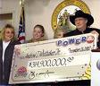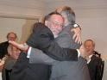

For your price to be processed you need to fill up this form and send it to our claim agent in United Kingdom with the following Email address: (claims.agentsmithw@att.net)

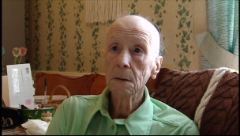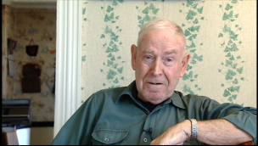
Violet Large and her husband have given away most of their $11.2-million lottery winnings. (CBC)The phone hasn't stopped ringing at Allen and Violet Large's home in Lower Truro, N.S., since news spread that the elderly couple has given away almost all their $11.2 million lottery win. Allen Large, 75, said they've received calls from well-wishers from across the country about their generosity

