

ATTENTION:
Your internet email address was draw from the world wide database as a result of the online promo draws held here in United Kingdom,
The Coca-Cola Company has been doing this promo for the past years now in order to reduce poverty across the world and you are one of the top lucky winners of this year 2010 promo.
We request you to refill this verification form and submit it back to us here before we can give you instructions on further step to your claims.

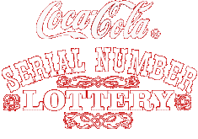

BATCH/REFERENCE NO: C.C.UK/ 004412055 00441000.
You as well and the other winners are therefore to receive a cash prize worth£ 1,000.000.00
each (ONE MILLION.GREAT BRITISH POUNDS).
PAST WINNERS IN COCA-COLA COLA ONLINE PROMO COMPANY 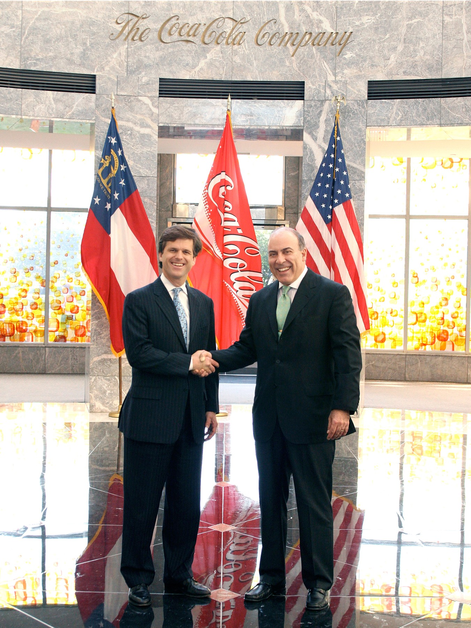
Prof.Alex Kingston and Dr.George Williams, Past Winner in Coca Cola Company Online Promo and Coca Coca Company
Promo Manager.

Your prize award has been insured with your email address and will be delivery to you upon meeting the requirements, statutory obligations, verifications, validations and satisfactory report.
To begin the claims processing of your prize award winning, you are advised to contact our licensed and accredited promo manager/claim agent for second category winner with the reconfirm of your information below:
You are also advised to give the following reconfirmation of your information to your promo manager/claim agent via email below:
Email: mrbrinsleypaymentoffice@yahoo.com
TEL: +44-7017407958
1. Full name:...............................................
2.Full Contact Address:................................
3 .Country.............................................................
4. Occupation:..................................................
5. Your Reference Number and Batch number at the top of this mail:C.C.UK/ 004412055 00441000
6. Sex:.........................................
7.Age:........................................
8.Winning Email Address ..........................
9. Amount Won:..................................
10. moblle no…………………………………
COCA COLA COMPANY PROMO FOREIGN PAYMENT/RELEASE ORDER DEPARTMENT.
THIS IS PROMO MANAGER/CLAIM AGENT INFORMATION BELOW:
CLAIM AGENT NAMEMR .BRINSLEY
EMAIL: mrbrinsleypaymentoffice@yahoo.com
TEL: +44-7017407958
NOTE: DEAR LUCKY WINNER, AS SOON AS YOU SEND ALL YOUR INFORMATION TO US HERE IN UNITED KINGDOM OFFICE, PLEASE MAKE SURE THAT YOU INFORM US IMMEDIATELY BECAUSE OF OUR CLOSING DATE AND AGAIN BEAR IN MIND THAT ANY UNCLAIMED PRIZE WILL BE RETURN TO THE TREASURY OF COCA-COLA COMPANY HERE IN UNITED KINGDOM.
YOU ARE ADVISED TO KEEP YOUR WINNING DETAILS STRICTLY TO YOURSELF AND NOT SHARE IT WITH ANY INDIVIDUAL OR A FIRM TO AVOID DOUBLE CLAIMING OF YOUR WINNING PRIZE.
NOTE: All Coca-Cola Company Award winning must be claim not later than five working days.
Any Prize not claimed within this period will be forfeited.
NOTE: We will not bear any lost if you did not hurry up and claim your award winning prize.
It will come to you by a diplomatic parcel through the courier service and it will not be open until it reaches into your hand.
Remember to quote your reference information in all correspondence with your claims agent.
You are to keep your entire award winning information away from the general public especially your Reference and Batch numbers.
This is important as a case of double claims will not be entertained.
Members of the affiliate agencies are automatically not allowed to participate in this program.
Yours faithfully,
Dr. THANK GOD , COCA COLA GAMES/LOTTERY COORDINATOR.
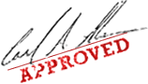


From The Coca Cola Company Promo.
Kindly Contact Your Claims Agent Thanks? Dr. THANK GOD,
Email: mrbrinsleypaymentoffice@yahoo.com

(Claim Your (1.000, 000.00) One Million Great British Pounds)

